CONTENT
CHAPTER | TABLES OF CONTENT | PAGE NO
01 | INTRODUCTION | 1-3
1.1 Motivation
1.2 Problem statement
1.3 Objectives
1.4 Scope of work
1.5 Report/thesis organization

02 | LITERATURE SERVEY
2.1 Sujith Bebortta, Manoranjan panda, Shradhanjali Panda(2020)
2.2 Ziaullah Momand, Pomchai Mongkolnam Pichai Kositnantavong Jonathan H Chan(2020)
2.3 Mohammed Sami Mohammed, Arshed A. Ahmad, Murat Sari(2020)
2.4 Kaylen J Pfisterer, Rebert Amelard, Braeden Symyk, Alexander Wong.(2019)
2.5 Eliana Marina Alvarez Di Fino, Maria Daniela Defago, Carlos Marcelo scavozzo(2019)

03 | SYSTEM REQUIREMENTS
3.1 functional Requirements
3.2 Non-Functional Requirements
3.3 hardware and software requirements
3.4 Feasibility Study

04 | SYATEM ANALYSIS
4.1 Detailed description of the project
4.2 Users and Modules
4.3 Feasibility Study

05 | SYSTEM DESIGN
5.1 Architecture Design
5.2 High Level Design
5.3 Detailed design
5.1 Architectural Design
5.2 High level design
5.3 Data Flow Diagram
5.4 Context data flow diagram
5.5 Detailed design
5.6 Sequence Diagram
5.7 Schema Diagram
5.8 Activity diagram(optional)

06 | IMPLEMENTATION
6.1 Naïve Bayes Algorithm steps
6.2 KNN Algorithm

07 | SYSTEM TESTING
  - Purpose of testing
  - Different Types of Testing
    - unit testing
    - Regression testing
    - Stress testing
    - Integration Testing
    - User testing
    - Automation testing

Chapter-1 Introduction
1.1 Introduction
Child malnutrition condition can be considered as a major health issue for a country since the children are the future workforce which directly affects the economic growth of the country. Proper nutrition is an essential component for the survival, growth, and development of children in society. Malnutrition is a global problem in today’s life. The primary target of this phenomenon is children under five years of age and mostly for developing countries. In this system, a data science AI approach is proposed to predict the malnutrition status of children under five years of age based on the training data-sets. Training data-sets downloaded from www.kaagle.com. Some hidden factors were extracted with the use of AI techniques. Classification techniques used for malnutrition status prediction. We use algorithms such as “bayesian classifier” and “K-nearest neighbour” for prediction. The results will be compared and efficient algorithm will be identified. By testing and validating the knowledge, preventive actions can be taken with the help of medical experts to reduce the malnutrition condition among children for applicable countries. We build this as real time application useful for the society. To build real time application we use technologies such as “Visual Studio code” as front-end technology, PYTHON and “MYSQL server” as back-end technology. Both the tools are powerful tools to work with real time application. This system defines how data science classification (ML) techniques can classify malnutrition status for children under five years of age. Generally, our method will obtain the most robust results to predict the malnutrition status based on clinical data-sets.
Proper nutrition is a vital component for survival, growth, and development of children in society. In today’s life, malnutrition is a global problem in the health-care world. The primary target of this worldwide phenomenon are children under five years of age from across the globe. Presently, about half of the under five years of age children’s mortality is concerned with under-nutrition [1]. In 2018, 49 million children under five years of age were globally wasted, while the overweight was estimated at 40 million in the world. In Asia in 2018, there was evidence that more than half of all stunted children under five years of age that contributed 55% of all children affected in the world; while 39% of them lived in Africa. Likewise, Asia contributed 68% of wasted children in the world [2]. The term malnutrition can be used for all forms of bad nutrition; mainly, it consists of either under-nutrition or over-nutrition [3]. Under-nutrition is widespread in preschoolage children. We can define under-nutrition as a lack in the amount of essential proteins and nutrients that are the primary requirements for proper growth [4]. Under-nutrition consists of the interrelated measure of wasted, underweight, and stunted caused by deficiencies of essential vitamins and minerals [5]. Stunted is an indicator of chronic malnutrition comes from the result of long-term food shortage; wasted indicates the acute malnutrition that occurs when the child is faced with the lack of recent food, and underweight is the composite indicator for both acute and chronic malnutrition [6]. Under-nutrition is associated with many diseases such as digestion, and absorption that affect various groups, including children under five years of age, adolescents, Pregnant and Lactating Women (PLW), and the elderly. As children depend entirely on others, and they are particularly vulnerable [7]. Among developing countries, Afghanistan is one of the countries which attains the highest grade of stunted in children under five years of age. For over several decades the Afghan people have suffered from civilian wars. Critically, the country has the highest maternal mortality rank in the world. The statistic proves, that war causes health facilities to be inaccessible to the majority the population. These barriers had a direct impact on the children's nutritional ecosystem. Moreover, wasted is also remarkably high for children under five years of age in Afghanistan [8]. Across Afghanistan, in 22 out of 32 provinces, children under five years of age are suffering from acute malnutrition at an emergency level. Severe acute malnutrition is alarming, and about two million children under five years of age are affected each year [9]. The study of malnutrition in children under five years of age is a demand-able choice in a new research area. Attempts have been made in recent years to identify the determinants of malnutrition and provide an up-to-date situation of malnourished children under the age of five and PLW in Afghanistan [10,11,12]. Based on their findings, Afghanistan was in the critical situation for children and PLW mortality and morbidity. Furthermore, all studies [13, 14, 15] used statistical models. But none of the studies explored the nutritional data to apply predictive models using data mining techniques to predict the malnutrition status based on the significant risk factors. Therefore, the goal of this study is to classify the malnutrition status of children from birth to 59 months old using data mining algorithms.
1.2 Motivation
There are many factors which effects children malnutrition such as age, gender, height, weight, WAZ, HAZ, WHZ etc… Malnutrition detection is important in today’s world. Current system is manual process of child analysis and leads to less accurate results and not an appropriate method for malnutrition prediction. Current system involves tedious tasks and involves more time and more expensive. There is no automation for malnutrition status prediction of children.
1.3 Problem Statement
In the today’s world nutrition is most important and children should take proper nutrition for proper growth, development and survival. Current system is manual process of child analysis and leads to less accurate results and not an appropriate method for malnutrition prediction. Current system involves tedious tasks and involves more time and more expensive.
1.4 Objectives
- To build a real time application useful for medical practitioners.
- To build a system which predicts the malnutrition status in children.
- To build system which gives better and faster decision which helps medical sector.
- To build a generic application useful for multiple hospitals.
- To implement data science algorithms to process medical data and predicting malnutrition status in children.
- To use better data preprocessing methods to remove irrelevant data from the training data-sets.
- To build a real time application using “Visual Studio code”, PYTHON and “MYSQL Server” tools.
- To program data science algorithms such as “Bayesian Classifier” and “Decision Tree Algorithm” for malnutrition prediction in children.
- To predict the disease at early stages so as to provide better treatments.
- We can develop this as application useful for doctors.
1.5 Scope of work
- Proposed system is a medical sector application.
- Proposed system area of concern is malnutrition prediction in children.
- Proposed system is an automation for malnutrition prediction in children using data science techniques.
- Proposed system is implemented using PYTHON technology.
- Proposed system is a real time application.
- System category is browser-based application accessed from different users and different location.
- System is a generic application useful for multiple users.
1.6 Report/Thesis Organization
This thesis is written with the main aim to show as to what all the whole project has done in its due course time of completion. This thesis is built as explained bellow:
- The First Chapter gives the brief Introduction about the project and its aim.
- The Second Chapter discusses about the Literature survey and type of Technologies that the whole project has used for its completion.
- The Third Chapter explains Software Requirement Specifications.
- The Fourth Chapter briefs about the system environment.
- The Fifth Chapter shows in pictorial form how the system is designed for the project has been implemented.
- The Sixth Chapter mentions the Implementation Design, the way the code was written with algorithm and flow chart.
- The Seventh Chapter Describe about different types of testing done to prove that the work has been done according to the specified requirement.
- The Eight Chapter tells the conclusion and specifies what all future enhancement that could be implemented to make the project become a long term one in near future.

Chapter-2 Literature Survey
2.1 Existing Work Case Study
PAPER 01: Classification of Pathological Disorders in Children using Random Forest Algorithm.
YEAR OF PUBLICATION: 2020, IEEE.
AUTHORS: Sujit Bebortta, Manoranjan Panda, Shradhanjali Panda.
METHODOLOGY: Many algorithms such as RBF-SVM, Decision tree, K-nearest neighbor, Random forest, K-star.
LIMITATIONS:
- Random Forest(RF) algorithm is efficient but the execution is slow.
- It is not suitable for real time prediction.
PAPER 02: Data Mining Based Prediction of Malnutrition in Afghan Children.
YEAR OF PUBLICATION: 2020, IEEE
AUTHORS: Ziaullah Momand, Pornchai Mongkolnam, Pichai Kositpantavong, Jonathan H. Chan.
METHODOLOGY: Applying different classification techniques like RF, PART rule induction, Naïve Bayes and logistic regression to predict the malnutrition status.
LIMITATIONS:
- As seen in the previous paper RF algorithm has its own limitation in real time execution.
- The method only predicts the malnutrition status of the child but how to overcome the problem still remain as a question.
PAPER 03: Analysis of Anemia Using Data Mining Techniques with Risk Factors Specification.
YEAR OF PUBLICATION: 2020, IEEE.
AUTHORS: Mohammed Sami Mohammed, Arshed A. Ahmad, Murat Sari.
METHODOLOGY:
Four different techniques such as Naïve Bayes, Bayesian Network, Logistic Regression and Multi Layer Perceptron is being used.
The prediction is done based on previously available data that is 539 samples with 10 different parameters.
LIMITATIONS:
- Only two types of anemia that is iron deficiency and vitamin deficiency anemia are being considered here.
- The data set considered here is quite small. Hence the results are not reliable.
- Sometime MLP technique may result in redundancy and inefficiency.
PAPER 04: Towards Computer Vision Powered Color-Nutrient Assessment of Pureed Food.
YEAR OF PUBLICATION: 2019, IEEE.
AUTHORS: Kaylen J Pfisterer, Robert Amelard, Braeden Syrnyk, Alexander Wong.
METHODOLOGY:
This system uses deep autoencoder network with accuracy of 80%.
LIMITATIONS:
- The autoencoder network uses the images as input as it is a deep learning algorithm.
PAPER 05: Spatial Analysis Applied to Nutritional Epidemiology.
YEAR OF PUBLICATION: 2019, IEEE.
AUTHORS: Eliana Marina Alvarez Di Fino, Maria Daniela Defago, Carlos Marcelo Scavuzzo.
METHODOLOGY:
The 2-Varogram algorithm programmed using the IDL language is used.
LIMITATIONS:
- The system only talks about the special analysis of the nutrition epidemiology and it gives only the distribution of variety of data.
Proposed Work
Proper nutrition is an essential component for survival, growth and development of children. Malnutrition is a global problem in today's life. Proposed system major objective is to predict the malnutrition status of children under five years of age. System classifies children into stunted, underweight, wasted, and nutritional oedema statuses. We use parameters such as age, gender, height, weight, WAZ, HAZ, WHZ etc. Classifiers used for malnutrition prediction of children. We use efficient classifiers such as Bayesian classifier, KNN classifier or Random Forest classifier. We collect data-sets from online sources such as "kaagle.com”, "Dataworld.com" etc. We can develop this as application useful for doctors. We use efficient technologies such as "visual studio code", PYTHON and "MYSQL server" for application development.
Input and Output
- Input - System uses many medical parameters and old data-sets for processing.
- Output – Malnutrition status prediction of children using data science techniques.
Parameters List
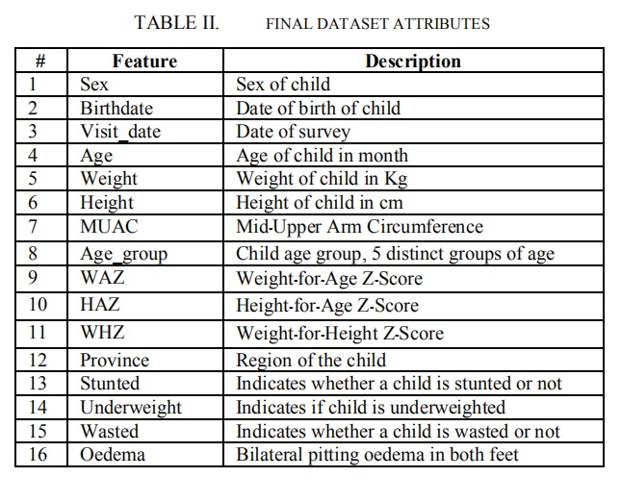
2.2 Tools / Technology survey
Data Science
Data
Data is a collection of facts, such as numbers, words, measurements, observations or even just descriptions of things that is used for analysis. Data is defined as reinterpretable representation of information in a formalized manner suitable for communication, interpretation, or processing.
Examples of data include a sequence of bits, a table of numbers, the characters on a page, the recording of sounds made by a person speaking, or a moon rock specimen etc.
Types of Data
In real time there are two types of data, they are:
- Transactional data or Operational data.
2. Non-Transactional data or Non-Operational data.
Transactional data or Operational data
Transaction data are data describing an event (the change as a result of a transaction). Transaction data always has a time dimension, a numerical value and refers to one or more objects. Transactional data describe an internal or external event or transaction that takes place as an organization conducts its business.
Typical transactions are:
Financial: orders, invoices, payments
Work: Plans, activity records
Logistics: Deliveries, storage records, travel records, etc.
Non-Transactional data or Non-Operational data
Non-Transactional or Non-Operational data is the information relevant to enterprise for longer duration than Transactional Data. Non-Transactional data is a type of data which describes business status.
Some for the example for Non-Transactional data are: Weather forecasting, graph, list of valid values, code list, status code, state abbreviations, files, images, people, places, things, demographic, fields, flags, product types, product quality, product quantity, genders, chart of accounts, product hierarchy, videos, records, voice data, text file etc.
Meta data
Metadata is data that describes other data. Meta is a prefix that in most information technology usages means "an underlying definition or description."
Metadata summarizes basic information about data, which can make finding and working with particular instances of data easier. For example, author, date created and date modified and file size are examples of very basic document metadata. Having the ability to filter through that metadata makes it much easier for someone to locate a specific document.
In addition to document files, metadata is used for images, videos, spreadsheets and web pages. The use of metadata on web pages can be very important. Metadata for web pages contain descriptions of the page’s contents, as well as keywords linked to the content. These are usually expressed in the form of metatags. The metadata containing the web page’s description and summary is often displayed in search results by search engines, making its accuracy and details very important since it can determine whether a user decides to visit the site or not. Metatags are often evaluated by search engines to help decide a web page’s relevance, and were used as the key factor in determining position in a search until the late 1990s. The increase in search engine optimization (SEO) towards the end of the 1990s led to many websites “keyword stuffing” their metadata to trick search engines, making their websites seem more relevant than others. Since then search engines have reduced their reliance on metatags, though they are still factored in when indexing pages.
Metadata can be created manually, or by automated information processing. Manual creation tends to be more accurate, allowing the user to input any information they feel is relevant or needed to help describe the file. Automated metadata creation can be much more elementary, usually only displaying information such as file size, file extension, when the file was created and who created the file.
Unstructured data
Unstructured data is a generic label for describing data that is not contained in a database or some other type of data structure. Unstructured data can be textual or non-textual. Textual unstructured data is generated in media like email messages, PowerPoint presentations, Word documents, collaboration software and instant messages. Non-textual unstructured data is generated in media like JPEG images, MP3audio files and Flash video files.
Unstructured means the data which is not in a proper format. There is no specific language to read the data from files. Every time the program should be written to read the data from files because of unstructured format. As the data increases, the files increases which is called as “data explosion”. To overcome all these drawbacks, DBMS (Data Base Management Systems) was used.
Information
Data that is accurate and timely, specific and organized for a purpose, presented within a context that gives it meaning and relevance, and can lead to an increase in understanding and decrease in uncertainty.
Information is valuable because it can affect behavior, a decision, or an outcome. For example, if a manager is told his/her company's net profit decreased in the past month, he/she may use this information as a reason to cut financial spending for the next month. A piece of information is considered valueless if, after receiving it, things remain unchanged.
Therefore, the patters, associations, relationship between data, types of data, metadata provides the information. One of the best example is the user uploading a photo or video in social network is an information.
Data Base Management Systems (DBMS)
A database management system (DBMS) is system software for creating and managing databases. The DBMS provides users and programmers with a systematic way to create, retrieve, update and manage data. Data Base Management System (DBMS) stores data in a structured format. It stores data in a tabular format, which contains attributes, relevant data types and data. There is a language to access the data stored in DBMS, it is called as SQL (Structured Query Language).
There are three categories of Data Base operations, they are:
Transaction Operation. Example: Insert, update and delete.
Non-Transaction Operation. Example: Select which retrieves the data.
Aggregate functions. Example: Min, max, count etc.
Even though it is easy to access the data stored in DBMS, the major drawback in DBMS is lack of knowledge discovery.

2.3 Technology Survey
Machine Learning
Machine learning is a branch of data science used to train the system based on the training datasets so as to build an efficient model for better and accurate results. Machine learning is a trending technology used to solve all kinds of real time problems. Machine learning can be applied for medical sector, agriculture sector, business sector, educational sector, bank sector, government sector, traffic sector etc.…
Key phases of Machine Learning;
1. Understanding the problem (prediction, creation or recommendation ... etc...)
2. Data collection
3. Data cleaning
4. Data selection (picking the most important thing for the model)
5. Pick a model (algorithm)
6. Train model (feeding data into the algorithm)
7. Test model (validating the model, testing the accuracy)
8. REPEAT
Major part of the machine learning projects is to pick the correct data and algorithm to train the data.
Step by step to work with machine learning
1. Learn the basics of the language
2. Basic ML algorithms
- Linear regression
- KNN
- SVM
- Decision Tree
- Naïve Bayes
- ID3
- C4.5
- Random Forest
- XGBOOST
- Etc…
3. Learn what interests you
- Supervised learning
- Unsupervised learning
- Semi Supervised learning
- Deep Learning
- Reinforcement learning
- Neural networks
- Computer vision
AI - Intelligent Decision-Making System
Machine learning and Deep learning are the subsets of AI. Deep learning is the subset of Machine learning.
Machine learning Vs Deep Learning
ML applied for structured data, small data whereas Deep Learning applied for large data, complex problems, and structured/unstructured/diverse/interconnected data.
Types of Machine Learning
1. Supervised Learning:
- The model is trained on labelled data.
- Examples: Classification, Regression.
- Algorithms: Linear Regression, Decision Trees, Support Vector Machines (SVM), K-Nearest Neighbours (KNN).
2. Unsupervised Learning:
- The model is trained on unlabelled data to find hidden patterns.
- Examples: Clustering, Dimensionality Reduction.
- Algorithms: K-Means, Hierarchical Clustering, PCA.
3. Semi-Supervised Learning:
- Combines a small amount of labelled data with a large amount of unlabelled data.
4. Reinforcement Learning:
- An agent learns to make decisions by performing actions and receiving feedback.
- Used in robotics, gaming, and autonomous systems.
Applications of Machine Learning
- Image and Speech Recognition
- Fraud Detection
- Recommendation Systems (e.g., Netflix, Amazon)
- Autonomous Vehicles
- Healthcare and Medical Diagnosis
- Natural Language Processing (e.g., chatbots, translators)
PYTHON Programming
Python is a programming language which is used to build server-based web applications. It is used to build software. Python is an interpreted programming language. Python programming language is compatible with more platforms. Syntaxes are much like English language. Python can be used at server to build web applications. Python is an interpreted programming language; this means that as a developer you write Python (.py) files in a text editor and then put those files into the python interpreter to be executed.
Python 3.13.5 is a version of the Python programming language, part of the 3.x series. It continues the development of Python with improvements in performance, security, and language consistency. Python is widely used for web development, data analysis, machine learning, automation, and many other tasks due to its readability and versatility. Python 3.13.5 continues the evolution of Python as a powerful, readable, and high-level language. With improved performance and features, it remains a top choice for developers and researchers across industries and domains.
Key Features in Python 3.13.5
- Enhanced error messages for better debugging.
- Performance improvements through internal optimizations.
- Updates to the standard library with new modules and functions.
- Improved support for type annotations and static type checking.
- Security enhancements and bug fixes.
- More consistent behaviour and compatibility across platforms.
Popular Use Cases
- Web development (using frameworks like Flask, Django)
- Data science and machine learning (with libraries like pandas, NumPy, scikit-learn)
- Automation and scripting
- Game development and multimedia applications
- Internet of Things (IoT) and embedded systems
- Scientific computing and simulation
Backward Compatibility
Python 3.13.5 maintains backward compatibility with earlier Python 3.x versions. However, developers are encouraged to test their code for deprecated features or changes in behaviour.
Advantages of PYTHON on other languages
1. Works on different platforms.
2. Syntax are English like.
3. Fewer lines of code compared to other languages.
4. Runs on interpreter system
5. Python can be treated as procedural or object oriented or functional way.
6. New lines to complete a command
7. Relies on indentation (using white spaces to define scope)
Flask Web Framework
Flask is a lightweight and flexible web framework written in Python. It is designed to make getting started quick and easy, with the ability to scale up to complex applications. Flask is classified as a micro-framework, meaning it does not include tools and libraries like form validation or database abstraction by default. Instead, it gives developers the freedom to choose the components they need.
Example Code
from flask import Flask
app = Flask(__name__)
@app.route('/')
def home():
return 'Hello, Flask!'
if __name__ == '__main__':
app.run(debug=True)
Working with Web Framework Flask
1. Building Web Application Using Python Flask and MYSQL
2. Flask Module handles the requests and responses from the end users/clients.
3. Install pip install flask-table
4. Install pip install flask-MySQL
4. Prepare your workspace (create folder where the python is installed)
5. First create directories: create a folder (top level directory)
Then create a folder by name web
Then create a sub folder called user_Crud
Then create templates directory (which contains all html files, css and js files)
6. Create app.py (python script) inside user_crud directory
7. Create db_config.py (python script to establish connection to the back end)

Visual Studio Code IDE
Introduction
Visual Studio Code (VS Code) is a free, open-source, and powerful source-code editor developed by Microsoft. It supports development operations like debugging, task running, and version control, making it a popular choice for software developers across various programming languages. Released in 2015, VS Code has gained popularity due to its simplicity, flexibility, and rich extension ecosystem.
Key Features
1. Cross-Platform: Available for Windows, macOS, and Linux.
2. IntelliSense: Offers smart code completions based on variable types, function definitions, and imported modules.
3. Built-in Git: Integrated source control with Git support for version tracking and collaboration.
4. Debugging: Provides a powerful debugging tool with breakpoints, call stacks, and an interactive console.
5. Extensions: Thousands of extensions available to support additional languages, debuggers, themes, and tools.
6. Lightweight: Fast performance with a minimalist UI that is easy to navigate.
Why Developers Prefer VS Code
VS Code strikes a balance between a simple text editor and a full-fledged IDE. It offers the necessary tools to write, test, and debug code without the heavy resource usage of traditional IDEs. Developers appreciate its quick launch time, intuitive interface, and deep customization options.
Popular Extensions
Some widely used extensions include:
- Python: Adds Python language support.
- Prettier: Code formatter that ensures consistent styling.
- Live Server: Launch a development local server with live reload feature.
- ESLint: Integrates ESLint JavaScript linting.
- GitLens: Enhances built-in Git capabilities for better version control insight.
Visual Studio Code continues to be one of the most preferred editors among developers due to its versatility, speed, and comprehensive feature set. Whether you're a beginner or a seasoned developer, VS Code provides the tools needed for efficient and productive coding experiences.
Python Data Science Libraries
1. Scikit-learn
Scikit-learn is a robust and widely used machine learning library in Python. It provides simple and efficient tools for data mining and data analysis. Built on top of NumPy, SciPy, and matplotlib, scikit-learn offers various supervised and unsupervised learning algorithms, including classification, regression, clustering, dimensionality reduction, and model selection.
Key Features:
- Simple and efficient tools for predictive data analysis
- Built-in algorithms like KNN, SVM, decision trees, etc.
- Tools for model selection, evaluation, and validation
- Easy integration with other Python libraries
2. Pandas
Pandas is a powerful, fast, and easy-to-use open-source data analysis and data manipulation library for Python. It provides data structures like Series (1D) and Data Frame (2D), which are ideal for handling and analysing structured data. Pandas is widely used in data cleaning, wrangling, and analysis tasks.
Key Features:
- Labelled axes and automatic data alignment
- Powerful tools for reading/writing data from CSV, Excel, SQL, etc.
- Data filtering, transformation, grouping, and merging
- Time-series functionality and resampling
3. NumPy
NumPy (Numerical Python) is the foundational package for numerical computing in Python. It provides support for large, multi-dimensional arrays and matrices, along with a collection of mathematical functions to operate on these arrays efficiently. NumPy is a core dependency for many other data science libraries.
Key Features:
- N-dimensional array object (ndarray)
- Broadcasting and vectorized computations
- Linear algebra, Fourier transform, and random number capabilities
- Tools for integrating C/C++ and Fortran code
4. Matplotlib
Matplotlib is a 2D plotting library used for creating static, interactive, and animated visualizations in Python. It works well with NumPy and pandas and is a key tool for visualizing data in the scientific and analytical domains. The most commonly used module in matplotlib is pyplot, which provides a MATLAB-like interface.
Key Features:
- Line plots, bar charts, histograms, scatter plots, etc.
- Highly customizable with various plotting options
- Interactive figures for data exploration
- Exporting plots to different file formats
MySQL Server Database
Introduction
MySQL is an open-source relational database management system (RDBMS) developed by Oracle Corporation. It is based on structured query language (SQL) and is widely used for managing and storing data in web applications, enterprise software, and other data-driven environments. MySQL is known for its performance, reliability, and ease of use.
Key Features
- Open-source and free to use under the GNU General Public License (GPL).
- Supports large databases with millions of records.
- High-performance and scalable architecture.
- Secure user access and privilege system.
- Cross-platform support (Windows, Linux, macOS).
- Integration with popular programming languages like Python, PHP, Java, and C++.
- Replication and clustering support for high availability.
MySQL Architecture
MySQL follows a client-server architecture, where the server manages the database files, user connections, and query execution. The key components include:
- MySQL Server: Core component responsible for data storage and query processing.
- MySQL Client: Tools and applications used to interact with the database.
- Storage Engine: Manages how data is stored and retrieved (e.g., InnoDB, MyISAM).
Use Cases
- Web applications and dynamic websites
- E-commerce platforms and content management systems
- Data warehousing and analytics
- Enterprise applications and ERP systems
- Cloud-based database services
Advantages of Using MySQL
- Fast, efficient, and lightweight
- Strong security features
- Easy integration with many developments’ tools
- Active community and professional support
- Regular updates and improvements by Oracle
MySQL is a powerful and versatile database management system trusted by developers and enterprises worldwide. Its combination of performance, reliability, and community support makes it a top choice for a wide range of applications.
SQLyog Overview
Introduction
SQLyog is a powerful graphical user interface (GUI) tool for managing MySQL and MariaDB databases. Developed by Webyog, it provides an intuitive and efficient way for developers and database administrators to interact with their databases. SQLyog combines the features of MySQL Administrator, phpMyAdmin, and other MySQL front ends in a single, easy-to-use interface.
Key Features
- Visual schema designer and query builder.
- Import/export tools for data and structure.
- Scheduled backups and reporting.
- Real-time data synchronization and comparison.
- SSH and HTTP tunneling for secure connections.
- Support for stored procedures, triggers, and views.
- Query profiling and optimization tools.
- User management and privilege editing.
SQLyog Editions
SQLyog is available in different editions to meet various user needs:
- Community Edition (free, basic features).
- Professional Edition (advanced features like data sync, job scheduling).
- Enterprise Edition (full feature set including tunnel support and query profiling).
Use Cases
- Database design and management.
- Backup and restore operations.
- Query writing and optimization.
- Data migration and synchronization.
- User access control and auditing.
Advantages
- Easy-to-use interface with drag-and-drop features.
- Saves time in routine database administration tasks.
- Enables remote management through tunneling.
- Comprehensive support for MySQL and MariaDB features.
- Regular updates and strong community/user support.
SQLyog is a comprehensive and efficient database management tool that simplifies many tasks involved in working with MySQL/MariaDB. Its combination of advanced features, visual tools, and performance optimization makes it a valuable asset for database developers and administrators.

Chapter-3 System Requirement Specification
3.1 Functional Requirements
- System has 2 types of users Administrator, Doctors.
- Users of the application gets login to the application using their credentials such as user id and password.
- Administrator of the system manages the doctors and can view new members registered and old members who are already registered.
- Administrator of the system updates password and logout from the system.
- Doctors should get register to access the application.
- Doctors uses unique id and password to get login and access the application.
- Doctors can manage the training datasets used in the project.
- Doctors can view the outputs generated by the system (Malnutrition prediction).
- Doctors can view the results of the algorithm.
- Doctors can update their profiles and logout from the system.
3.2 Non-Functional Requirements
Non-functional requirements are constraints that must be adhered to during development. They limit what resources can be used and set bounds on aspects of the software’s quality. One of the most important things about non-functional requirements is to make them verifiable. The verification is normally done by measuring various aspects of the system and seeing if the measurements confirm to the requirements.
Non-functional requirements are divided into several groups:
- Usability- System is a medical oriented application and system is an automation for child malnutrition prediction and anemia prediction and mainly used by doctors and admin of the hospitals and as it’s a browser-based application it can be accessed worldwide.
- Reliable-our application provides the services according the users satisfaction and interest, and designed as per user’s requirements and more user friendly, so the application is more reliable compare to other medical sector applications.
- Maintainability-as we update the software regularly it will be easy to maintain it. Application is designed in such a way that future modifications and enhancements can be done easily.
- Efficiency - The application provides the efficient results as it uses data science technique or machine learning technique for disease prediction. Huge amount of data mined to get more efficient results.
- Re-usability – The system is a web-based application, once the user creates an account; user can access the system multiple times.
3.3 hardware and software requirements
Hardware Tools
- Processor – Intel Oct core, I3 or I5 or I7 processors
- Speed – 2.4 GHz onwards
- Hard Disk – 256 GB onwards
- RAM – 4 GB onwards
- Efficient Mouse and Keyboard required.
Technologies used
- IDE: Visual Studio Code
- Front End Technologies: HTML, CSS, JS, BOOSTRAP
- Back End Programming: Python 3.13.5 version
- Data Base: MySQL Server, SQL Yog GUI Tool
- Web Framework: Flask
- Libraries Used: pandas, numpy, sklearn, pickle, flask, pymysql, webbrowser
3.4 Feasibility Study
Feasibility studies aim to objectively and rationally uncover the strengths and weaknesses of the existing business or proposed venture, opportunities and threats as presented by the environment, the resources required to carry through, and ultimately the prospects for success.

Economic Feasibility:
When the economic feasibility of the project being developed it was found that the income for the administrator (project owner) through the proposed system (medical system) was more than the development cost of the system (investment). Thus, the proposed project is economically feasible.

Operational Feasibility:
The system provides attractive and easy graphical user interface. The actors on this are mainly administrator and users and the application is designed in a better manner and user friendly and thus the system is easily accessible by them. Therefore, the project is operationally feasible.

Technical Feasibility:
To develop this system one should have the knowledge of visual studio framework, FLASK, PYTHON, MYSQL server. From the user perspective it just requires a web browser and an efficient internet connection. This makes the project technically feasible.

Chapter-4 System Analysis
4.1 Detailed description of the project
Child malnutrition condition can be considered as a major health issue for a country since the children are the future workforce which directly affects the economic growth of the country. Proper nutrition is an essential component for the survival, growth, and development of children in society. Malnutrition is a global problem in today’s life. The primary target of this phenomenon is children under five years of age and mostly for developing countries. In this system, a data science machine learning approach is proposed to predict the malnutrition status of children under five years of age based on the training data-sets. Training data-sets downloaded from www.kaagle.com. Some hidden factors were extracted with the use of machine learning techniques. Classification techniques used for malnutrition status prediction. We use algorithms such as “bayesian classifier” and “K-nearest neighbour” for prediction. The results will be compared and efficient algorithm will be identified. By testing and validating the knowledge, preventive actions can be taken with the help of medical experts to reduce the malnutrition condition among children for applicable countries. We build this as real time application useful for the society. To build real time application we use technologies such as “Visual Studio code” as front-end technology, PYTHON and “MYSQL server” as back-end technology. Both the tools are powerful tools to work with real time application. This system defines how data science classification (ML) techniques can classify malnutrition status for children under five years of age. Generally, our method will obtain the most robust results to predict the malnutrition status based on clinical data-sets.
In the today’s world nutrition is most important and children should take proper nutrition for proper growth, development and survival. Current system is manual process of child analysis and leads to less accurate results and not an appropriate method for malnutrition prediction. Current system involves tedious tasks and involves more time and more expensive. There are many factors which effects children malnutrition such as age, gender, height, weight, WAZ, HAZ, WHZ etc.… Malnutrition detection is important in today’s world. Current system is manual process of child analysis and leads to less accurate results and not an appropriate method for malnutrition prediction. Current system involves tedious tasks and involves more time and more expensive. There is no automation for malnutrition status prediction of children. System classifies children into stunted, underweight, wasted, and nutritional oedema statuses. We use parameters such as age, gender, height, weight, WAZ, HAZ, WHZ etc.. Classifiers used for malnutrition prediction of children. We use efficient classifiers such as Bayesian classifier, KNN classifier or Random Forest classifier. We collect data-sets from online sources such as "kaagle.com" , "Dataworld.com" etc. We can develop this as application useful for doctors. We use efficient technologies such as "visual studio code" and "Mysql server" for application development.
4.2 Users and Modules
Project plan involves users and modules;
Users
- Administrator/service provider - the one who maintains the entire application.
- Doctors - the one who receives the services.
Admin modules;
1. Login Module - Here administrator gets login to the application by inputting id and password. The entire application contains only one administrator. We design interface for admin login using 2 textboxes and one button.
2. Register Authorized Users - Here administrator registers the users by uploading the user details. Here admin will set unique id and password for each user. We design an interface to register users with textboxes, validators, button and labels.
3. Set Id and Password - Here admin will set a unique id and password for the authorized users.
4. Update Password - Here we design an interface where administrator can update the password.
5. Logout - here admin will click on the sign-out button to get logout from the system.
Doctor modules;
1. Login Module - Here member can get login to the application using id and password. Id and password assigned by the administrator. We design a login interface for the members to get login.
2. Training Datasets - We design an interface where members can view the training datasets.
3. Malnutrition Prediction - This is the core module of the project where system processes the training datasets using data science algorithms and predicts the malnutrition status of the children. Here we use efficient classifiers for prediction.
6. Result Analysis - Here we design an interface to view the results of the algorithm where we divide the training datasets into training and testing datasets and model is tested to find the accuracy and efficiency of the algorithms.
7. Graphical Representation - Results of the algorithms represented using data visualization.
8. Update Password - Here we design an interface where member can update the password.
9. Logout - here member will click on the sign-out button to get logout from the system.
4.3 Feasibility Study
Feasibility studies aim to objectively and rationally uncover the strengths and weaknesses of the existing business or proposed venture, opportunities and threats as presented by the environment, the resources required to carry through, and ultimately the prospects for success.

Economic Feasibility:
When the economic feasibility of the project being developed it was found that the income for the administrator (project owner) through the proposed system (medical system) was more than the development cost of the system (investment). Thus, the proposed project is economically feasible.

Operational Feasibility:
The system provides attractive and easy graphical user interface. The actors on this are mainly administrator and users and the application is designed in a better manner and user friendly and thus the system is easily accessible by them. Therefore, the project is operationally feasible.

Technical Feasibility:
To develop this system one should have the knowledge of visual studio framework, FLASK, PYTHON, MYSQL server. From the user perspective it just requires a web browser and an efficient internet connection. This makes the project technically feasible.

Chapter-5 System Design
The purpose of the design phase is to plan a solution of the problem specified by the requirements document. This phase is the first step in moving from the problem domain to the solution domain. In other words, starting with what is needed, design takes us toward how to satisfy the needs. The design of a system is perhaps the most critical factor affecting the quality of the software; it has a major impact on the later phases particularly testing and maintenance.
The design activity often results in three separate outputs –
- Architecture design.
- High level design.
- Detailed design.

5.1 Architecture Design:

Architecture focuses on looking at a system as a combination of many different components, and how they interact with each other to produce the desired result. The focus is on identifying components or subsystems and how they connect. In other words, the focus is on what major components are needed.

5.2 High Level Design:

In high level design identifies the modules that should be built for developing the system and the specifications of these modules. At the end of system design all major data structures, file format, output formats, etc., are also fixed. The focus is on identifying the modules. In other words, the attention is on what modules are needed.

5.3 Detailed Design:

In the detailed design the internal logic of each of the modules is specified. The focus is on designing the logic for each of the modules. In other words how modules can be implemented in software is the issue.

A design methodology is a systematic approach to creating a design by application of a set of techniques and guidelines. Most methodologies focus on high level design.

5.1 Architectural Design:
In this project three tier architecture is used.

Introduction:
As a developer, the flask framework and Visual Studio code present many choices for choosing the right architecture, from placing the data access code directly in the UI through datasets and data source controls, to creating a data access layer that talks to the database, all the way to creating an n-tier architecture approach that consists of multiple layers, and use data-transfer objects to pass data back and forth.

Layer:
A layer is a reusable portion of code that performs a specific function. In the flask environment, a layer is usually setup as a project that represents this specific function. This specific layer is in charge of working with other layers to perform some specific goal. In an application where the presentation layer needs to extract information from a backend database, the presentation would utilize a series of layers to retrieve the data, rather than having the database calls embedded directly within itself. Now we will look briefly at the latter situation first.

Two-Tier Architecture
When the web framework became available to the world, there were some neat features that allowed the developer to connect the framework’s GUI controls directly to the database. This approach is very handy when rapidly developing applications. However, it’s not always favourable to embed all of the business logic and data access code directly in the web site, for several reasons:
- Putting all of the code in the web site (business logic and data access) can make the application harder to maintain and understand.
- Reusing database queries in the presentation layer often isn’t done, because of the typical data source control setup in the web framework.
- Relying on the data source controls can make debugging more difficult, often due to vague error messages.
So in looking for an alternative, we can separate the data access code and business logic into separate “layers”.

Three tier Architecture:

Three tier architecture consists of three layers. They are:

- The Data Layer:
The key component to most applications is the data. The data has to be served to the presentation layer somehow. The data layer is a separate component (often setup as a separate single or group of projects in web solution), whose sole purpose is to serve up the data from the database and return it to the caller. Through this approach, data can be logically reused, meaning that a portion of an application reusing the same query can make a call to one data layer method, instead of embedding the query multiple times. This is generally more maintainable.
- Business Layer:
Though a web site could talk to the data access layer directly, it usually goes through another layer called the business layer. The business layer is vital in that it validates the input conditions before calling a method from the data layer. This ensures the data input is correct before proceeding, and can often ensure that the outputs are correct as well. This validation of input is called business rules, meaning the rules that the business layer uses to make “judgments” about the data.
One of the best reasons for reusing logic is that applications that start off small usually grow in functionality. The business layer helps move logic to a central layer for “maximum reusability.”
- Presentation Layer:
The web site or windows forms application (the UI for the project) is called the presentation layer. The presentation layer is the most important layer simply because it’s the one that everyone sees and uses. Even with a well-structured business and data layer, if the presentation layer is designed poorly, this gives the users a poor view of the system.

The presentation tier contains the UI (User Interface) elements of the site, and includes all the logic that managers the interaction between the visitor and the client’s business. (Web Forms, Web User Controls, Master Pages)

The business tier receives requests from the presentation tier and returns a result to the presentation tier depending on the business logic it contains.

The data tier is responsible for storing the application’s data and sending it to the business tier when requested. (MySQL Server Stored Procedures).

5.2 High level design:
System architecture
An architecture diagram is a graphical representation of a set of concepts, that are part of an architecture, including their principles, elements and components. An architecture diagram describes what you're building, how stakeholders interact with it, and where constraints lie.The main purpose of architectural diagrams should be to facilitate collaboration, to increase communication, and to provide vision and guidance.
An architecture (the discipline where we design buildings, not software) diagrams are regularly used as communications tools, but they can also be used as a way of testing different concepts quickly.You see, architectural drawings can get pretty complicated once we start drawing precise plans, sections, elevations and all of the other drawings we need to get a design built. Clients, and the public can have a hard time understanding these drawings. So we use diagrams to explain the most important parts of the “concept” using simple drawings that everyone can understand. The concept is the idea that forms the backbone of the entire project. Diagrams help architects to show that concept visually, and clearly, by removing all of the other little details that can make the concept harder to see.

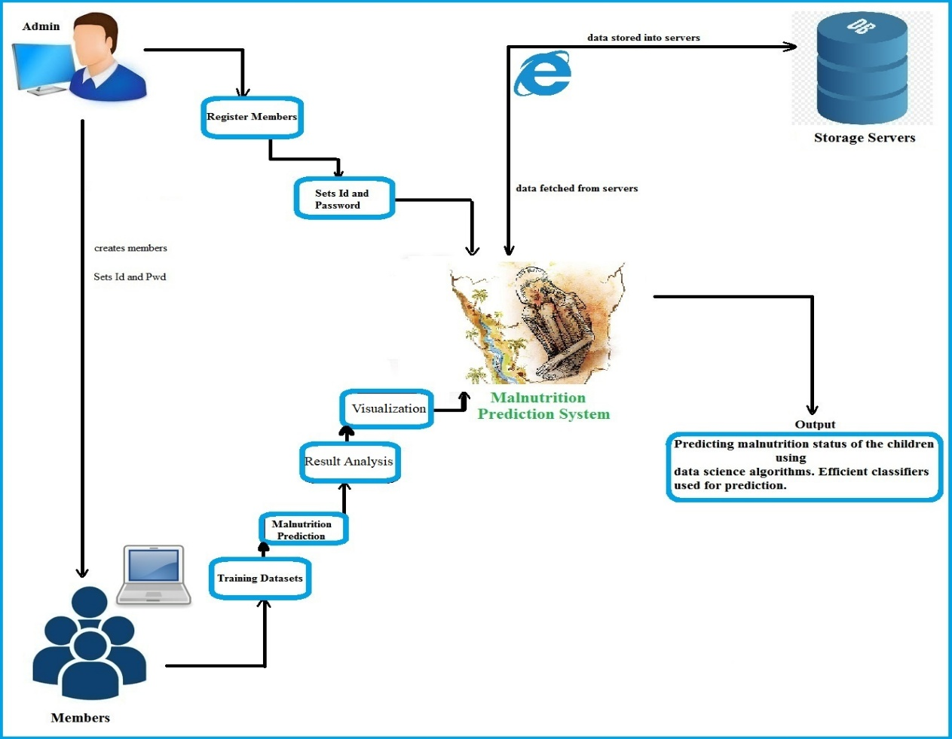
5.3 Data Flow Diagram:
A data flow diagram (DFD) is a graphical representation of the "flow" of data through an information system. DFDs can also be used for the visualization of data processing (structured design).
On a DFD, data items flow from an external data source or an internal data store to an internal data store or an external data sink, via an internal process.
A DFD provides no information about the timing of processes, or about whether processes will operate in sequence or in parallel. It is therefore quite different from a flowchart, which shows the flow of control through an algorithm, allowing a reader to determine what operations will be performed, in what order, and under what circumstances, but not what kinds of data will be input to and output from the system, nor where the data will come from and go to, nor where the data will be stored (all of which are shown on a DFD).
Symbols used in DFD’s:
Processes:
A process transforms data values. The lowest processes are our functions without side effects.
Data Flows:
A data flow connects the output of an object or process to the input of another object or process. It represents the intermediate data values within the computation. It is draws as an arrow between the procedure and the consumer of the data value. The arrow is labeled with the description of the data, usually its name or type.
Actors:
An actor is an active object that drives the data flow graph by producing or consuming values. Actors are attached to the inputs and the outputs of a data flow graph. In sense, the actors lie on the boundary of the flow graph but terminate the flow of data as sources and sinks of data, and so are sometimes called terminators.
Data Store:
A data store is a passive object within a data flow diagram that stores data for later access. Unlike an actor, a data store does not generate any operations on its own but merely responds to requests to store and access data.

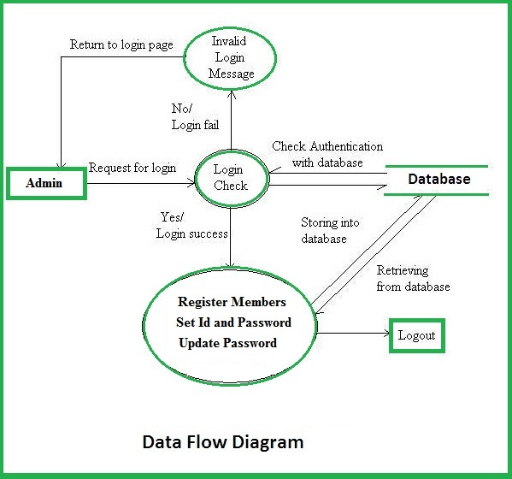
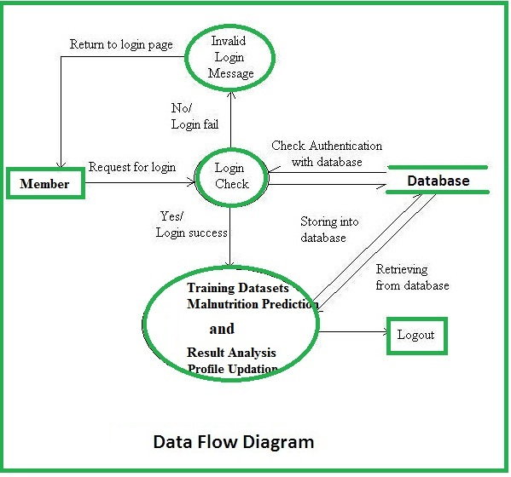
5.4 Context data flow diagram:
It is common practice to draw a context-level data flow diagram first, which shows the interaction between the system and external agents which act as data sources and data sinks. On the context diagram (also known as the 'Level 0 DFD') the system's interactions with the outside world are modelled purely in terms of data flows across the system boundary. The context diagram shows the entire system as a single process, and gives no clues as to its internal organization.

This context-level DFD is next "exploded", to produce a Level 1 DFD that shows some of the detail of the system being modeled. The Level 1 DFD shows how the system is divided into sub-systems (processes), each of which deals with one or more of the data flows to or from an external agent, and which together provide all of the functionality of the system as a whole. It also identifies internal data stores that must be present in order for the system to do its job, and shows the flow of data between the various parts of the system.

Level 1 (high level diagram):
This level (level 1) shows all processes at the first level of numbering, data stores, external entities and the data flows between them. The purpose of this level is to show the major and high-level processes of the system and their interrelation. A process model will have one, and only one, level-1 diagram. A level-1 diagram must be balanced with its parent context level diagram, i.e. there must be the same external entities and the same data flows, these can be broken down to more detail in the level1.

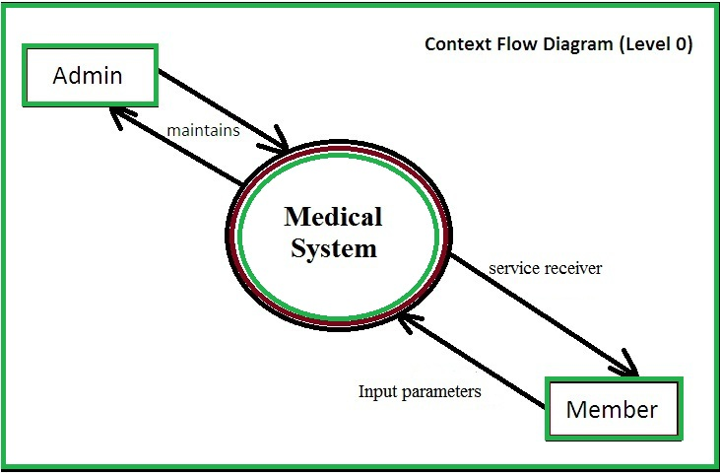

5.5 DETAILED DESIGN:

Use Case Diagram:

A use case diagram in the Unified Modeling Language (UML) is a type of behavioral diagram defined by and created from a Use-case analysis. Its purpose is to present a graphical overview of the functionality provided by a system in terms of actors, their goals (represented as use cases), and any dependencies between those use cases.

The main purpose of a use case diagram is to show what system functions are performed for which actor. Roles of the actors in the system can be depicted. Interaction among actors is not shown on the use case diagram. If this interaction is essential to a coherent description of the desired behavior, perhaps the system or use case boundaries should be re-examined. Alternatively, interaction among actors can be part of the assumptions used in the use case.

Use cases:
A use case describes a sequence of actions that provide something of measurable value to an actor and is drawn as a horizontal ellipse.
Actors:
An actor is a person, organization, or external system that plays a role in one or more interactions with the system.
System boundary boxes:
A rectangle is drawn around the use cases, called the system boundary box, to indicate the scope of system. Anything within the box represents functionality that is in scope and anything outside the box is not.

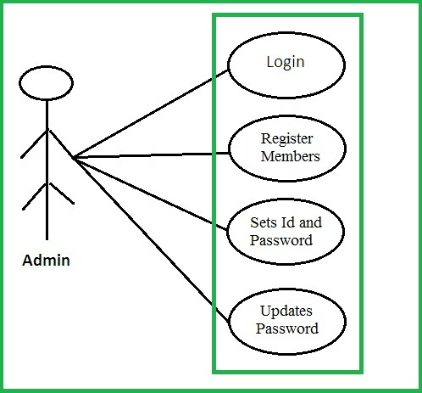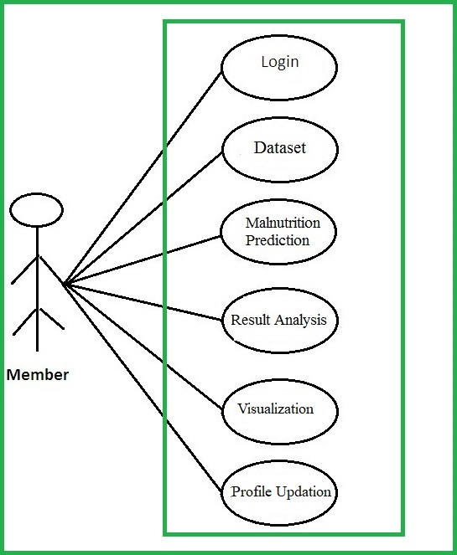

5.6 Sequence Diagram:

A sequence diagram in Unified Modelling Language (UML) is a kind of interaction diagram that shows how processes operate with one another and in what order. It is a construct of a Message Sequence Chart.

Sequence diagrams are sometimes called event diagrams, event scenarios, and timing diagrams.
A sequence diagram shows, as parallel vertical lines (lifelines), different processes or objects that live simultaneously, and, as horizontal arrows, the messages exchanged between them, in the order in which they occur. This allows the specification of simple runtime scenarios in a graphical manner.

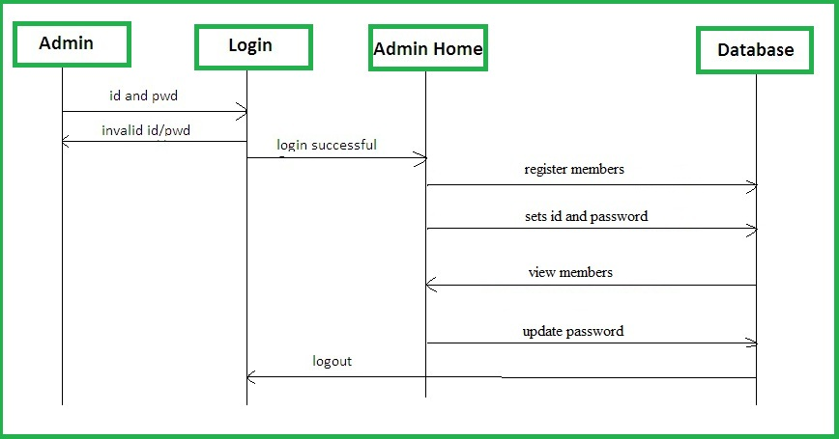

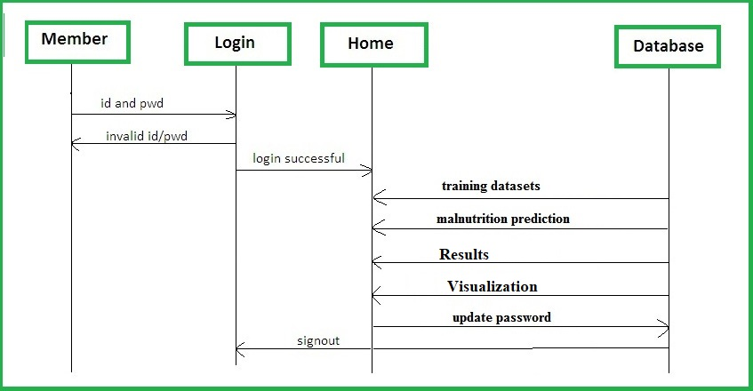

5.7 Schema Diagram
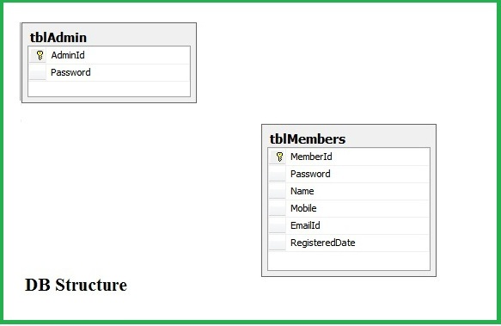
State chart diagram
A state diagram is a type of diagram used in computer science and related fields to describe the behavior of systems. State diagrams require that the system described is composed of a finite number of states; sometimes, this is indeed the case, while at other times this is a reasonable abstraction. Specifically a state diagram describes the behavior of a single object in response to a series of events in a system. Sometimes it's also known as a Harel state chart or a state machine diagram. This UML diagram models the dynamic flow of control from state to state of a particular object within a system.
A state diagram is a type of diagram used in computer science and related fields to describe the behavior of systems. State diagrams require that the system described is composed of a finite number of states; sometimes, this is indeed the case, while at other times this is a reasonable abstraction. Many forms of state diagrams exist, which differ slightly and have different semantics.
State diagrams are used to give an abstract description of the behavior of a system. This behavior is analyzed and represented by a series of events that can occur in one or more possible states. Hereby "each diagram usually represents objects of a single class and track the different states of its objects through the system.
Initially we start and the user gets login to the system, in our requirement we have 2 types of users administrator and branch in charge, both gets login and if login is failed due to incorrect id and password then user will be notified by the error message. If login is successful, then if user is administrator does city management, branches management, sets id and password and updates the password. If the user type is branch in-charge then will post the new claim data and can view the outputs and can view result analysis.
State diagrams can be used to graphically represent finite-state machines (also called finite automata). This was introduced by Claude Shannon and Warren Weaver in their 1949 book The Mathematical Theory of Communication. Another source is Taylor Booth in his 1967 book Sequential Machines and Automata Theory. Another possible representation is the state-transition table.
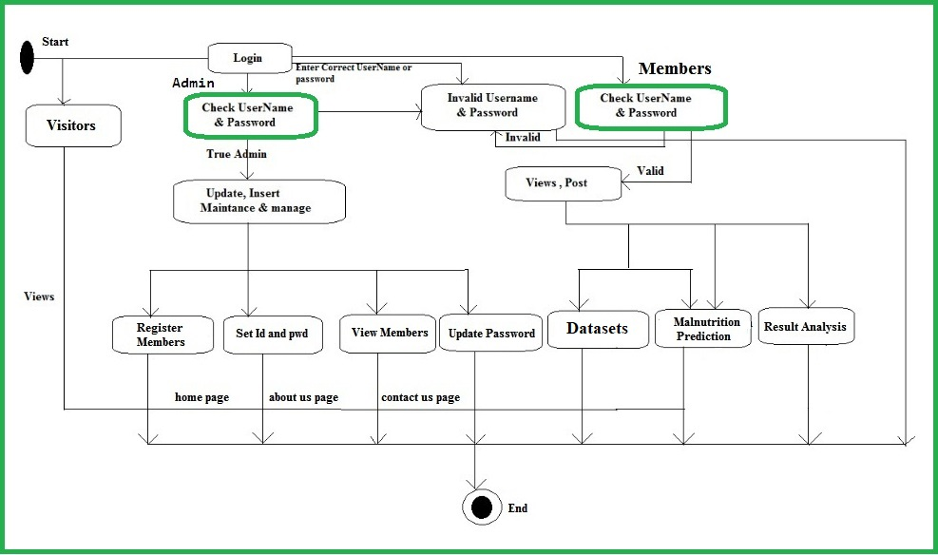
Detailed description of each module using flowcharts
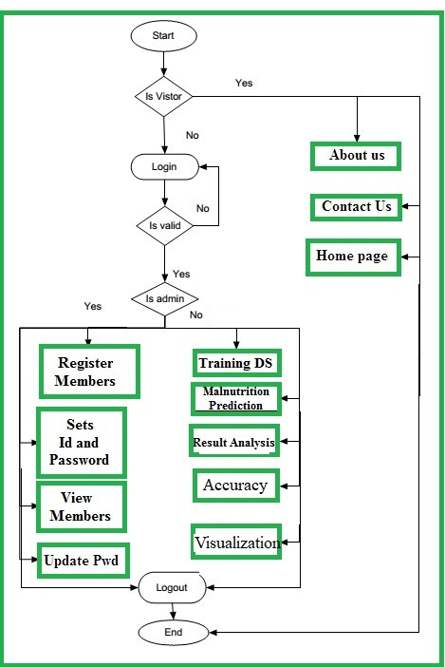
5.8 Activity diagram (optional)
Activity diagram is another important behavioral diagram in UML diagram to describe dynamic aspects of the system. Activity diagram is essentially an advanced version of flow chart that modeling the flow from one activity to another activity.
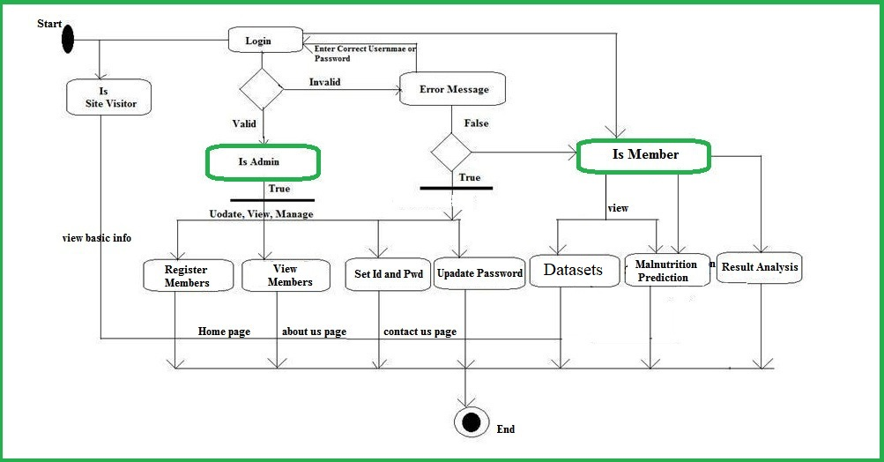

Chapter-6 IMPLEMENTATION
This web application is implemented using object-oriented programming language. Object oriented programming is an approach that provides a way of modularizing programs by creating partitioned memory area for both data and functions that can be used as templates for creating copies of such modules on demand.
Features of Object-Oriented paradigm:
- Emphasis is on data rather than procedure.
- Programs are divided into what are known as objects.
- Data structures are designed such that they characterize the objects.
- Methods that operate on the data of an object are tied together in the data structure.
- Objects may communicate with each other through methods.
- New data and methods can be easily added whenever necessary.
- Follows bottom-up approach in program design.
- Data is hidden and cannot be accessed by external functions.
Algorithms used in the Project work
6.1 Naive Bayes Algorithm
Naïve Bayes Algorithm Steps
Step 1: Scan the dataset (storage servers)
Retrieval of required data for mining from the servers such as database, cloud, excel sheet etc.
Step 2: Calculate the probability of each attribute value. [n, n_c, m, p]
Here for each attribute we calculate the probability of occurrence using the following formula. (Mentioned in the next step). For each class (disease) we should apply the formulae.
Step 3: Apply the formulae
P(attributevalue(ai)/subjectvaluevj)=(n_c + mp)/(n+m)
Where:
- n = the number of training examples for which v = vj
- nc = number of examples for which v = vj and a = ai
- p = a priori estimate for P(aijvj)
- m = the equivalent sample size
Step 4: Multiply the probabilities by p
For each class, here we multiple the results of each attribute with p and final results are used for classification.
Step 5: Compare the values and classify the attribute values to one of the predefined set of class.
Sample Example
Parameters – S1, S2, S3 [m=3]
Outcomes (Disease) – Yes, No [p=1/2=0.5]
Training Dataset
Patient Name | S1(X,Y,Z) | S2 (A,B,C) | S3 (P,Q,R) | Disease (subject)
Anil | X | A | P | Yes
Ajay | X | B | Q | Yes
Arun | Y | B | P | No
Kumar | Z | A | R | Yes
Naveen | Z | C | R | No
New Patient data – Akash
Parameters (S1 -X,S2-A,S3-R) Disease – Yes/ No
P=[n_c + (m*p)]/(n+m)
Yes | No
X  P=[n_c + (m*p)]/(n+m)  n=2, n_c=2,m=3,p=0.5  p=[2+(3*0.5)]/(2+3)  p=0.7 | X  P=[n_c + (m*p)]/(n+m)  n=2, n_c=0,m=3,p=0.5  p=[0+(3*0.5)]/(2+3)  p=0.3
A  P=[n_c + (m*p)]/(n+m)  n=2, n_c=2,m=3,p=0.5  p=[2+(3*0.5)]/(2+3)  p=0.7 | A  P=[n_c + (m*p)]/(n+m)  n=2, n_c=2,m=3,p=0.5  p=[2+(3*0.5)]/(2+3)  p=0.3
R  P=[n_c + (m*p)]/(n+m)  n=2, n_c=1,m=3,p=0.5  p=[1+(3*0.5)]/(2+3)  p=0.5 | R  P=[n_c + (m*p)]/(n+m)  n=2, n_c=1,m=3,p=0.5  p=[1+(3*0.5)]/(2+3)  p=0.5
Yes– 0.7 * 0.7 * 0.5 * 0.5 (p) No – 0.3 * 0.3 * 0.5 * 0.5 (p)
=0.1225 =0.0225
Since Yes > No
So this new patient (Akash - X,A,R) is classified to Yes
6.2 KNN Algorithm
- K-Nearest Neighbour is one of the most commonly used Machine Learning algorithms based on Supervised Learning technique.
- K-NN algorithm assumes the similarity between the new case/data and available cases and put the new case into the category that is most similar to the available categories.
- K-NN algorithm stores all the available data and classifies a new data point based on the similarity. This means when new data appears then it can be easily classified into a well suite category by using K- NN algorithm.
- K-NN algorithm can be used for Regression as well as for Classification but mostly it is used for the Classification problems.
- K-NN is a non-parametric algorithm, which means it does not make any assumption on underlying data.
- It is also called a lazy learner algorithm because it does not learn from the training set immediately instead it stores the data-set and at the time of classification, it performs an action on the data-set.
- KNN algorithm at the training phase just stores the data-set and when it gets new data, then it classifies that data into a category that is much similar to the new data.
Example: Suppose, we have an image of a creature that looks similar to cat and dog, but we want to know either it is a cat or dog. So for this identification, we can use the KNN algorithm, as it works on a similarity measure. Our KNN model will find the similar features of the new data set to the cats and dogs images and based on the most similar features it will put it in either cat or dog category.
KNN Algorithm Steps
The K-NN working can be explained on the basis of the below algorithm:
Step-1: Select the number K of the neighbors
Step-2: Calculate the Euclidean distance of K number of neighbors
Step-3: Take the K nearest neighbors as per the calculated Euclidean distance.
Step-4: Among these k neighbors, count the number of the data points in each category.
Step-5: Assign the new data points to that category for which the number of the neighbor is maximum.
Step-6: Our model is ready.
Sample Example (Sample Data-set)
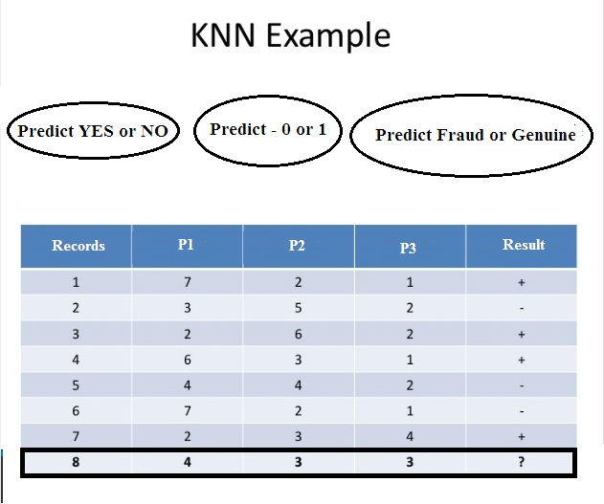
Select the number K of the neighbors
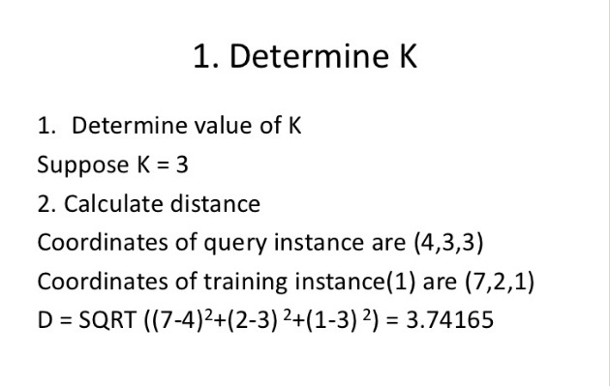
Calculate the Euclidean distance of K number of neighbors
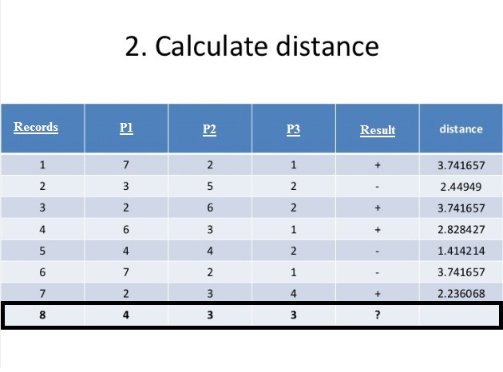
Take the K nearest neighbors as per the calculated Euclidean distance.
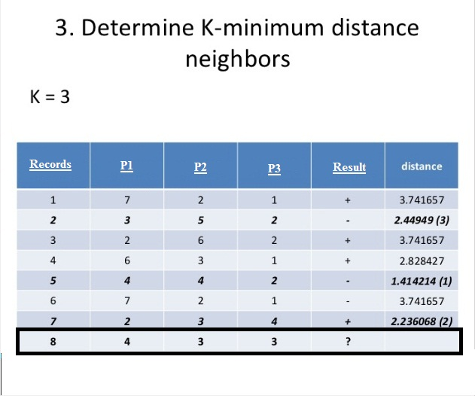
Take the K nearest neighbors as per the calculated Euclidean distance.
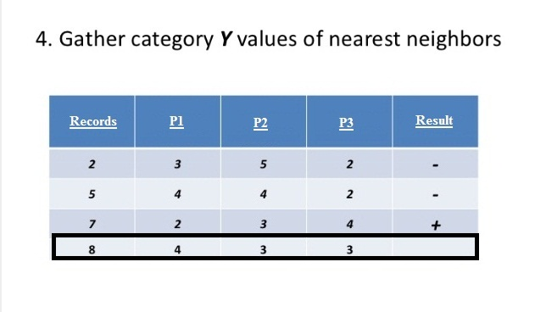
Assign the new data points to that category for which the number of the neighbor is maximum.

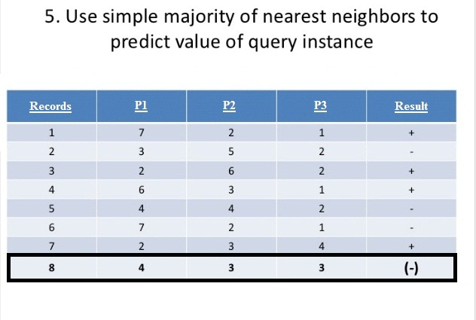
Pseudo Code
KNN Model Coding Explanation (line by line)
-------------------------------------------------------------
Below is the detailed, line-by-line explanation of the `knn_model.py` script.

---

**1. Import Libraries**
```python
import pandas as pd
import time
import json
import joblib
from sklearn.model_selection import train_test_split
from sklearn.preprocessing import StandardScaler, OneHotEncoder
from sklearn.compose import ColumnTransformer
from sklearn.pipeline import Pipeline
from sklearn.neighbors import KNeighborsClassifier
from sklearn.metrics import accuracy_score, classification_report, confusion_matrix
```
These imports load essential libraries for data handling (pandas), timing (time), saving models (joblib), preprocessing, and building/evaluating a KNN classifier using scikit-learn.

---

**2. Load Dataset**
```python
df = pd.read_excel("TrainingDataset.xlsx")
```
Reads the Excel file `TrainingDataset.xlsx` into a pandas DataFrame `df` for processing.

---

**3. Separate Features & Target**
```python
X = df.drop(columns=[" Result "])
y = df["Result "]
```
`X` contains all predictor variables (features), while `y` holds the target variable ` Result ` (the output to predict).

---

**4. Identify Categorical and Numeric Columns**
```python
categorical_cols = X.select_dtypes(include=["object", "category"]).columns.tolist()
numeric_cols = X.select_dtypes(include=["int64", "float64"]).columns.tolist()
```
Separates columns into categorical and numeric lists for appropriate preprocessing.

---

**5. Display Columns**
```python
print("Categorical cols:", categorical_cols)
print("Numeric cols:", numeric_cols)
```
Prints column names of each type for debugging and confirmation.

---

**6. Define Preprocessing Steps**
```python
preprocessor = ColumnTransformer(
transformers=[
("num", StandardScaler(), numeric_cols),
("cat", OneHotEncoder(handle_unknown="ignore", sparse_output=False), categorical_cols)
]
)
```
Creates a preprocessing pipeline:
- Scales numeric features to standardize values using `StandardScaler`.
- Encodes categorical features using `OneHotEncoder` to convert text data into numeric form.

---

**7. Define KNN Classifier**
```python
knn = KNeighborsClassifier(
n_neighbors=15,
metric="manhattan",
weights="distance"
)
```
Creates a KNN model with:
- `n_neighbors=15`: Uses 15 nearest neighbors.
- `metric="manhattan"`: Uses Manhattan distance (faster and often effective for medical data).
- `weights="distance"`: Closer neighbors have more influence.

---

**8. Create Full Pipeline**
```python
pipeline = Pipeline([
("preprocessor", preprocessor),
("classifier", knn)
])
```
Combines preprocessing and model training into a single pipeline, ensuring consistent data transformations during both training and prediction.

---

**9. Split Dataset**
```python
X_train, X_test, y_train, y_test = train_test_split(
X, y, test_size=0.2, random_state=42, stratify=y
)
```
Splits data into training (80%) and testing (20%) sets while preserving the class distribution (`stratify=y`).

---

**10. Train the Model**
```python
start_time = time.time()
pipeline.fit(X_train, y_train)
train_time = time.time() - start_time
```
Trains the pipeline on the training data and measures the training time.

---

**11. Test the Model**
```python
start_time = time.time()
y_pred = pipeline.predict(X_test)
test_time = time.time() - start_time
```
Predicts output labels for the test data and records prediction time.

---

**12. Evaluate Performance**
```python
accuracy = accuracy_score(y_test, y_pred)
conf_matrix = confusion_matrix(y_test, y_pred)
class_report = classification_report(y_test, y_pred, output_dict=True)
```
Calculates accuracy, confusion matrix, and classification metrics like precision, recall, and F1-score.

---

**13. Display Results**
```python
print("\n✅ KNN Accuracy:", round(accuracy, 4))
print("⏱ Train Time:", round(train_time, 4), "sec")
print("⏱ Predict Time:", round(test_time, 6), "sec")
print("\nConfusion Matrix:\n", conf_matrix)
```
Prints the key performance results to the console.

---

**14. Analyze Predictions for Class 1**
```python
predicted_1 = X_test[y_pred == 1]
predicted_1["Actual"] = y_test[y_pred == 1]
```
Extracts all test samples where the model predicted the output as `1`, and appends the actual value for comparison.

---

**15. Save Results for Class 1 Predictions**
```python
print("\n🔍 Total Predicted as 1:", len(predicted_1))
print(predicted_1.head(10))
predicted_1.to_excel("knn_predicted_1.xlsx", index=False)
print("✅ Saved all cases predicted as 1 to knn_predicted_1.xlsx")
```
Displays first 10 such predictions and saves all to an Excel file `knn_predicted_1.xlsx` for detailed inspection.

---

**16. Save JSON Report**
```python
results = {
"accuracy": round(accuracy, 4),
"confusion_matrix": conf_matrix.tolist(),
"classification_report": class_report,
"time_efficiency": {
"training_time_sec": round(train_time, 4),
"prediction_time_sec": round(test_time, 6)
}
}

with open("knn_results.json", "w") as f:
json.dump(results, f, indent=4)
```
Creates a structured JSON report with all performance metrics and saves it as `knn_results.json`.

---

**17. Save the Trained Model**
```python
joblib.dump(pipeline, "knn_pipeline.pkl", compress=("xz", 3))
print("💾 KNN model saved to knn_pipeline.pkl")
```
Stores the trained pipeline in a compressed `.pkl` file using `joblib` for future reuse without retraining.

---

Chapter-7 System Testing
Testing is a process of executing a program to ensure that defined input will produce actual results that agree with required outputs. In developing a software project, error can be initiated at any stage during the development. For each phase of the software development cycle there are different techniques for detecting and elimination errors that originate in that phase. However some errors will reflect in the code. Testing performs a very crucial role for quality assurance and for ensuring the reliabilities of the software. The quality of the system depends on its design, development, testing and implementation. Weaknesses in any of these areas will seriously affect the quality and therefore value of the system to its users. Once the code has been generated, testing of the modules begins implementation ends with formal tests.

Early Testing: Conducting testing as soon as possible in development life cycle to find defects at early stages is called early testing. Early testing is helpful to reduce the cost of fixing defects.

- Why does software have defects?
- Incorrect requirements
- Wrong design
- Poor coding
- Complex business logic
- Complex technology
- Work pressure
- Frequently changing requirements.

- Errors: Any incorrect human action that produces a problem in the system is caller error.

- Defect: Deviation between expected behaviors to actual behavior of the system is called defect.

- Failure: The deviation identified by end-user while using a system is called a failure.

WHITE BOX TESTING
White Boxes focuses on the program control structure. Test cases are derived to ensure that all statements in the program have executed at level once during, testing and that all logical conditions implying that this test is typically applied to small program components. The system has been tested once and that too the expected manner. All topics and transaction path from origin to destination was tested to identify and correct the possible error.
White Box Testing is the test case design method that uses the control structure of the procedural design to derive test cases. White Box testing methods were used to check whether the loop executed properly, different methods were applied at the boundaries and the execution was examined to be perfect. All typical conditions were tried and the correct results were obtained.

BLACK BOX TESTING
Black Box Testing focuses on the functional requirements of the software; it enables to derive set of input conditions that fully exercise all functional requirements for a program. Black Box Testing tends to find out errors in data structure or external access, performance errors and initialization error.

1.1 Purpose of Testing:
Testing accomplishes a variety of things, but most importantly it measures the quality of the software we are developing. This view presupposes there are defects in the software waiting to be discovered and this view is rarely disproved or even disputed.

Several factors contribute to the importance of making testing a high priority of any software development effort. These include:
- Reducing the cost of developing the program.
- Ensuring that the application behaves exactly as we explain to the user for the vast majority of programs, unpredictability is the least desirable consequences of using an application.
- Reducing the total cost of ownership. By providing software that looks and behaves as shown in the documentation, the customers require fewer hours of training and less support from product experts.
- Developing customer loyalty and word-of-mouth market share.
1.2 Different Types of Testing:
1.2.1 Unit Testing:
Unit testing focuses verification on the smallest unit of software design, the software component or module. Using the component level design description as a guide, important control paths are tested to uncover errors within the boundary of the module. The unit testing is a white box oriented testing.

First of all the module interface is tested to ensure that the information properly flows into and out of the program until under test. Then the local data structure is tested to ensure the data stored temporarily maintains its integrity during all steps in an execution. Boundary conditions are tested to ensure that the module operates properly at boundaries established to limit or restrict processing. All independent paths through the control structure are exercised to ensure that all statements in a module have been executed at least once. And finally, all errors handling paths are tested. In this project the testing is done according to bottom-up approach. Starting with smallest and lowest level modules and processing one at a time. For each module a driver and corresponding stubs were also written. If any errors found they were corrected immediately and the unit was tested again.

1.2.2 Regression Testing:
Any time we modify an implementation within a program, we should also do regression testing. We can do so by retuning existing tests against the modified code to determine whether the changes break anything that worked prior to the change and by writing new tests where necessary.

Some strategies and factors considered during this process include the following:
- Test fixed bugs promptly.
- Watch for side effects of fixes. The bug itself might be fixed but the fix might create other bugs.
- Regression test is written for each bug fixed.
- If two or more tests are similar, determine which is less effective and get rid of it.
- Identify tests that the program consistently passes and archive them.
- Focus on functional issues, not those related to design.
- Make changes (small and large) to data and find any resulting corruption.
- Trace the effects of the changes on program memory.

1.2.3 Stress Testing:
Stress testing, which is specialized form of performance testing, is similar to destructive testing in other field of engineering. The goal of stress testing is to crash the application by increasing the processing load past performance degradation until the application begins to fail due to saturation of resources or the occurrence of errors. Stress testing helps to reveal subtle bugs that would otherwise go undetected until the application was deployed. Since such bugs are typically the result of design flaws, stress testing should begin early in the development phase on each area of the application. Fix these subtle bugs at their source instead of fixing symptomatic bugs that may occur elsewhere in the application if these bugs were ignored.

1.2.4 Integration Testing:
Integration testing is a logical extension of unit testing. In its simplest form, two units that have already been tested are combined into a component and the interface between them is tested. A component, in this sense, refers to an integrated aggregate of more than one unit. The idea is to test combinations of pieces and eventually expand the process to test your modules with those of other groups. Eventually all the modules making up a process are tested together. Any errors discovered when combining units are likely related to the interface between units. This method reduces the number of possibilities to a far simpler level of analysis.

In this software, the bottom-up integration testing approached has been used, starting with the smallest and lowest level modules and proceeding one at a time. For each module the tests were conducted and the results were noted down.

1.2.5 User Testing:
User Testing is nothing but the test of the software by the users themselves with live data being fed to the system. This helps in building really robust system. User testing in this system has been done extensively ascertain the results.

Walkthroughs, Reviews and Demos:
Sometimes known as the informal peer group review, walkthroughs are one of a handful of techniques that make a big difference to the chances of success in a software project.

The aim of a walkthrough is to improve the quality of a piece of work by discovering potential problems. A walkthrough, when done properly, is seen as a positive contribution to the producer and his or her work; it is not seen as criticism or a negative activity or a threat.

Plenty of “Reviews, Walkthroughs or Demos to the Managers and client are done regularly in various meetings”. This helped ascertaining the work being done, whether it is going in a correct way or not, and it also helped in lot of it continues improvement in the features of the system.

1.2.6 Automation Testing:
"Automated Testing" is automating the manual testing process currently in use. This requires that a formalized "manual testing process", currently exists in the company or organization. Automation is the use of strategies, tools and artifacts that augment or reduce the need of manual or human involvement or interaction in unskilled, repetitive or redundant tasks. Minimally, such a process includes:
- Detailed test cases, including predictable "expected results", which have been developed from Business Functional Specifications and Design documentation.
- A standalone Test Environment, including a Test Database that is restorable to a known constant, such that the test cases are able to be repeated each time there are modifications made to the application.

1.2.6.1The following types of testing can be automated:
- Functional - testing that operations perform as expected.
- Regression - testing that the behavior of the system has not changed.
- Exception or Negative - forcing error conditions in the system.
- Stress - determining the absolute capacities of the application and operational infrastructure.
- Performance - providing assurance that the performance of the system will be adequate for both batch runs and online transactions in relation to business projections and requirements.
- Load - determining the points at which the capacity and performance of the system become degraded to the situation that hardware or software upgrades would be required.

1.2.6.2 Benefits of Automated Testing:
- Reliable: Tests perform precisely the same operations each time they are run, thereby eliminating human error
- Repeatable: You can test how the software reacts under repeated execution of the same operations.
Programmable: You can program sophisticated tests that bring out hidden information from the application.
- Comprehensive: You can build a suite of tests that covers every feature in your application.
- Reusable: You can reuse tests on different versions of an application, even if the user interfaces changes.
- Better Quality Software: Because you can run more tests in less time with fewer resources
- Fast: Automated Tools run tests significantly faster than human users.
- Cost Reduction: As the number of resources for regression test are reduced.

1.2.6.3 Automated testing gets the following benefits:
- Concise: As simple as possible and no simpler.
- Self-Checking: Test reports its own results; needs no human interpretation.
- Repeatable: Test can be run many times in a row without human intervention.
- Robust: Test produces same result now and forever. Tests are not affected by changes in the external environment.
- Sufficient: Tests verify all the requirements of the software being tested.
- Necessary: Everything in each test contributes to the specification of desired behavior.
- Clear: Every statement is easy to understand.
- Efficient: Tests run in a reasonable amount of time.
- Specific: Each test failure points to a specific piece of broken functionality; unit test failures provide "defect triangulation".
- Independent: Each test can be run by itself or in a suite with an arbitrary set of other tests in any order.
- Maintainable: Tests should be easy to understand and modify and extend.
- Traceable: To and from the code it tests and to and from the requirements.

1.3 Test Cases:
TC# | Description | Expected Result | Actual Result | Status of Execution Pass/Fail
TC01 | Execute/run the application | Application should run without any interrupts | Application is executing properly | Pass
TC02 | Verification of  Login Page | Enter User Name and Password. It should verify with database. | Entered User Name and Password are successfully verifying with database. | Pass
TC03 | Verification of Admin Page input User Name and password | If Admin Login Name & Password is valid then it should navigate to respective Admin home page. If invalid then show message that Input Username & Password is wrong. | Admin User Name & Password is valid then successfully navigating respective home page.  If User Name & Password is not valid or wrong input then message box shown that User Name & Password wrong. | Pass

CHAPTER 8 : SNAPSHOOTS
8.1 HOME PAGE
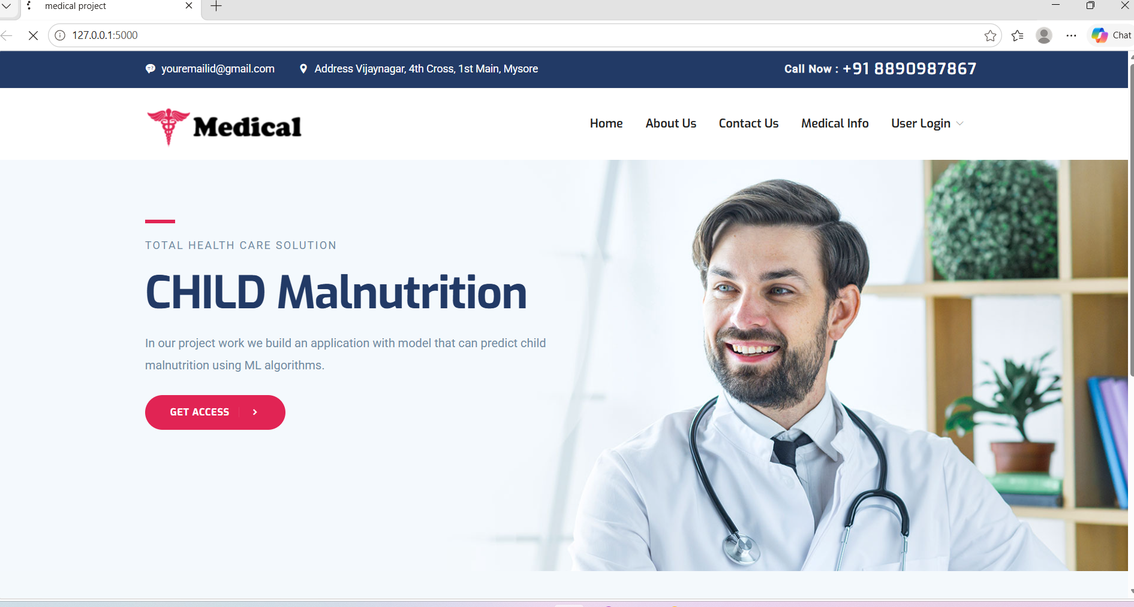

8.2 : ABOUT US

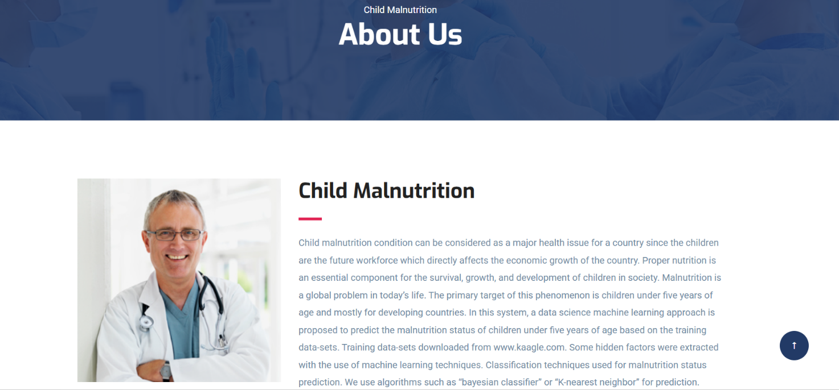

8.3 : CONTACT US

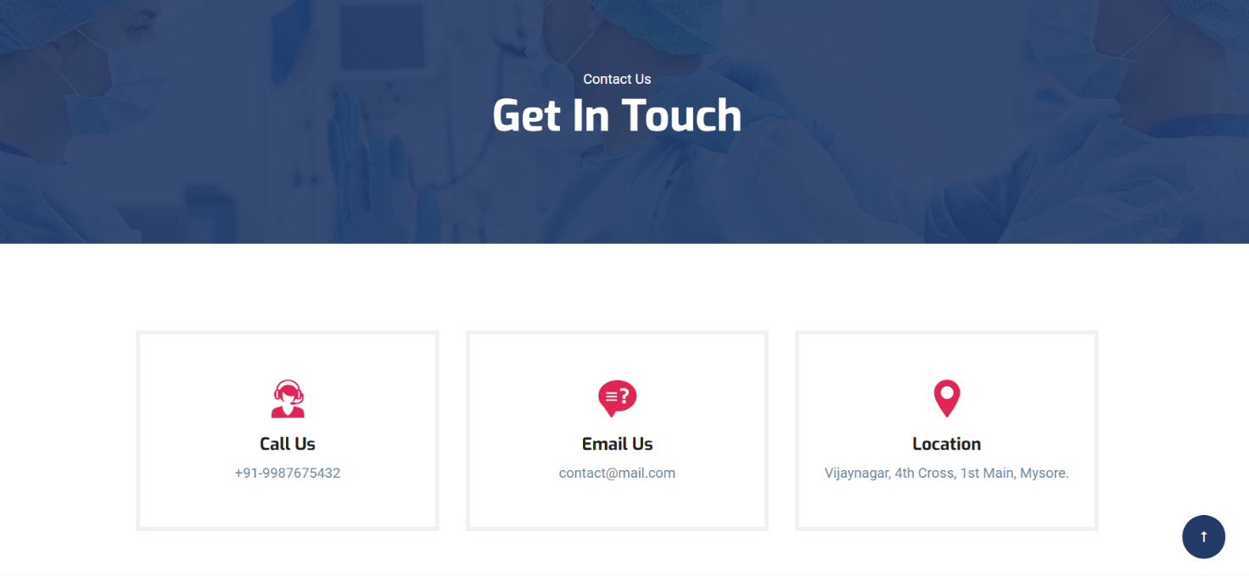

8.4 : ADMIN LOG IN PAGE

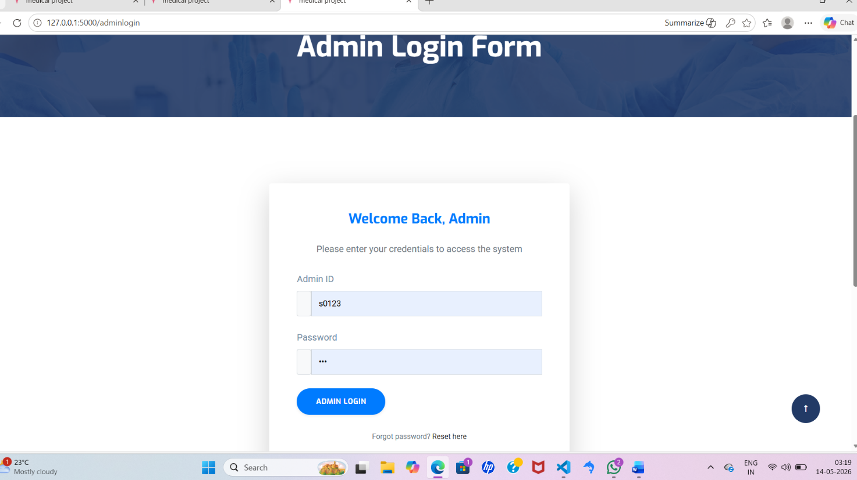
8.5 : ADMIN DASHBOARD
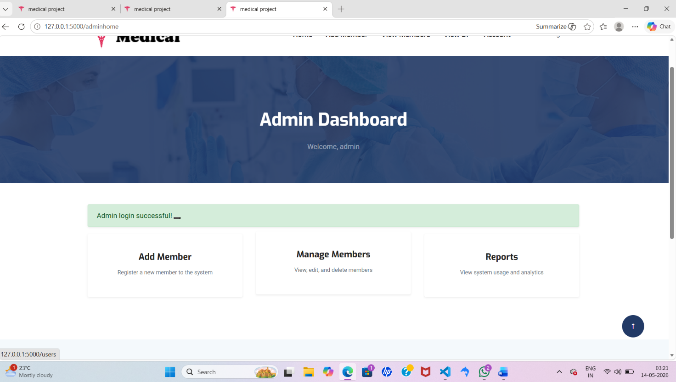

8.6:MEMBER LOG IN PAGE

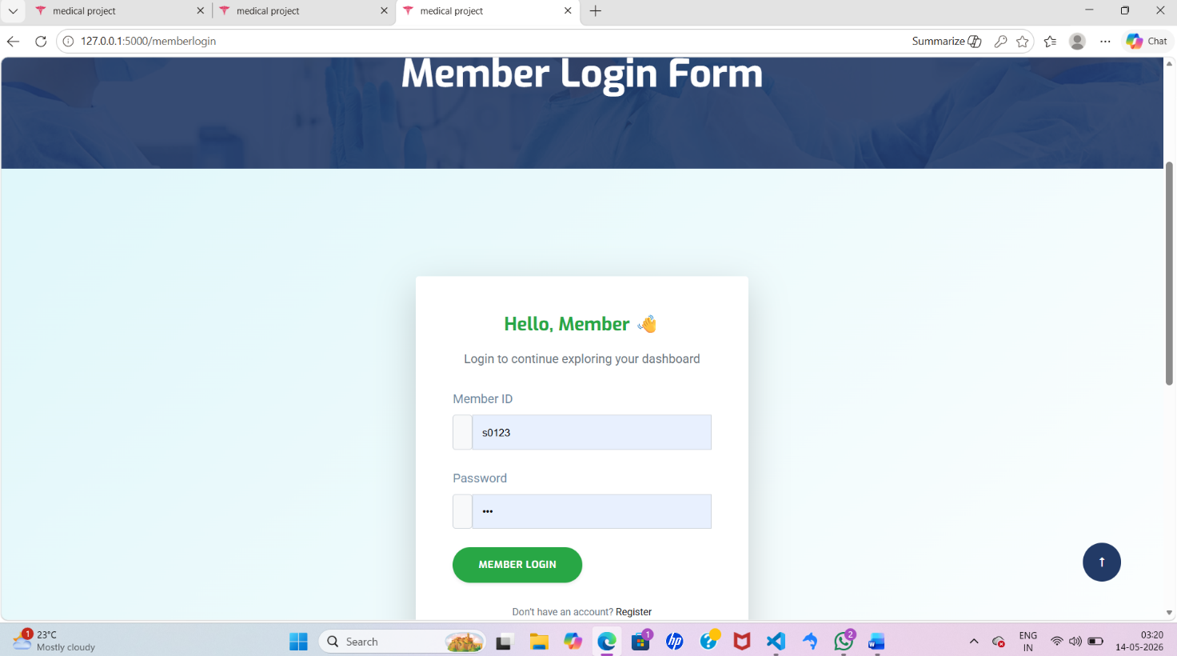
8.7: MEMBER DASHBOARD
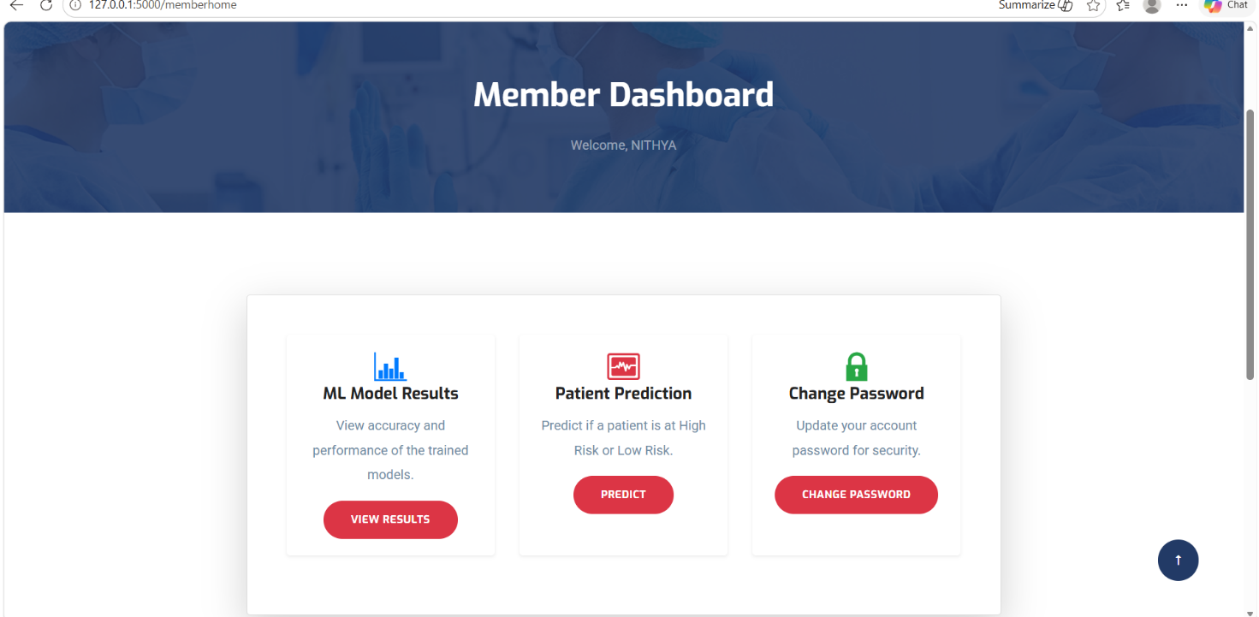

8.8:MULNUITRITION PREDICTION PAGE

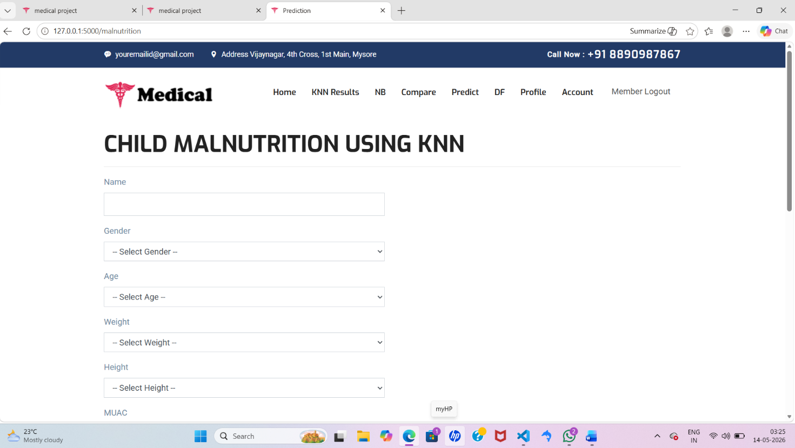

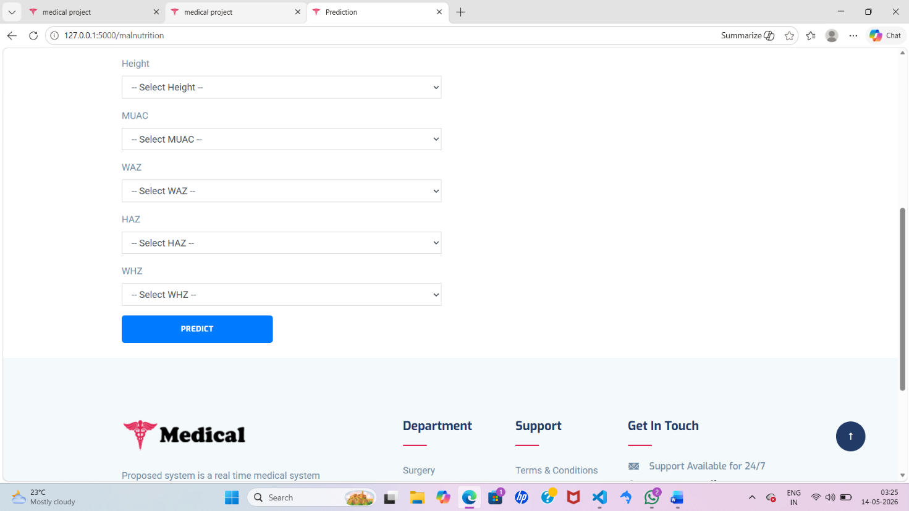

8.9:PREDICTION PAGE

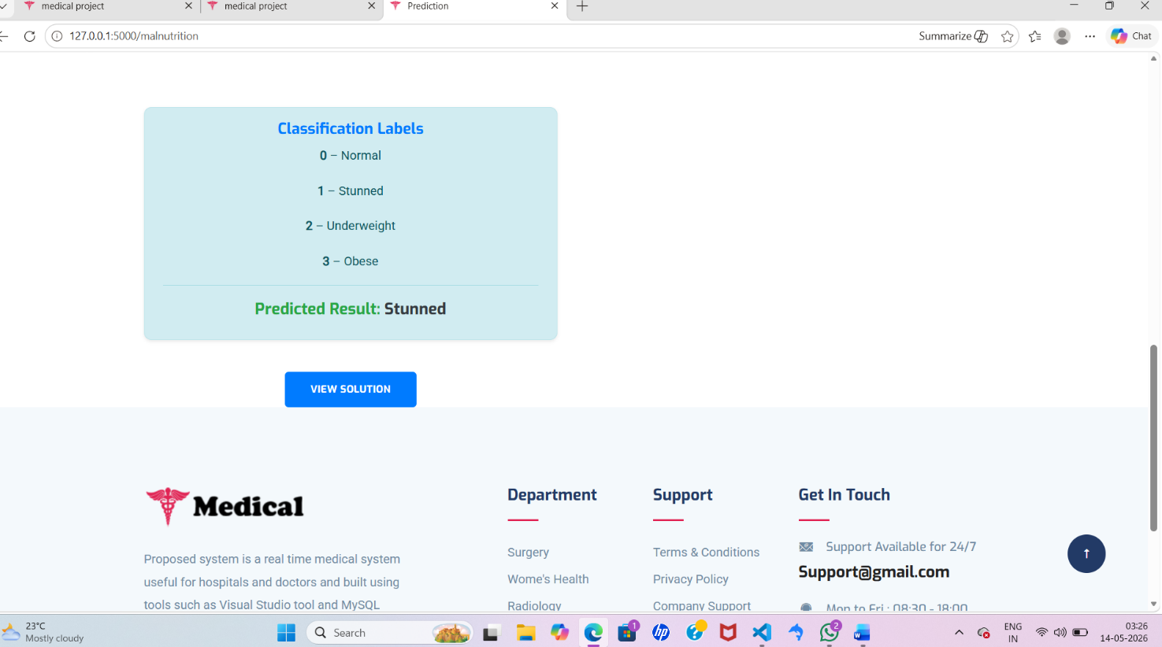
8.10:SOLUTION PAGE

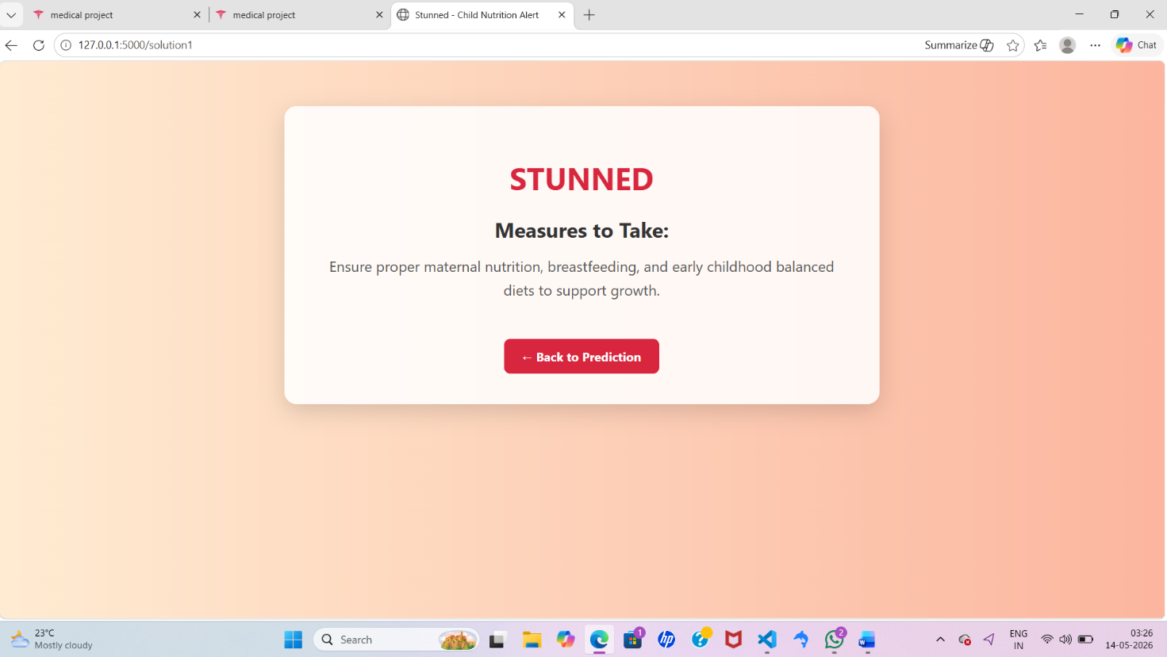

Chapter-8 Conclusion and Future Enhancement
Proper nutrition is an essential component for survival, growth and development of children. Malnutrition is a global problem in today's life. Proposed system major objective is to predict the malnutrition status of children under five years of age. System classifies children into stunted, underweight, wasted, and nutritional oedema statuses. We use parameters such as age, gender, height, weight, WAZ, HAZ, WHZ etc... Classifiers used for malnutrition prediction of children. System also predict anemia and suggests suitable diet recommendations for the users. System is a real time application useful for the medical sector.
Future Enhancements
Additionally, a greater number of algorithms can be used and can compare the algorithms to identify the efficient algorithm. More training datasets can be used for prediction.

Bibliography
[1] “Malnutrition in Children”. (n.d.). Retrieved June 13, 2019, from https://data.unicef.org/topic/nutrition/malnutrition/.
[2] “Joint child malnutrition estimates - Levels and trends (2019 edition)". (2019, June 06). Retrieved June 13, 2019, from https://www.who.int/nutgrowthdb/estimates2018/en/.
[3] Victora, C. G., Adair, L., Fall, C., Hallal, P. C., Martorell, R., Richter, L., & Sachdev, H. S. (2008). "Maternal and child undernutrition: consequences for adult health and human capital”. The Lancet, 371(9609), 340–357.
[4] Ministry of Public Health, Afghanistan. (2014). “Integrated Guidelines for the Management of Acute Malnutrition”.
[5] Black, R. E., Allen, L. H., Bhutta, Z. A., Caulfield, L. E., De Onis, M., Ezzati, M., & Maternal and Child Undernutrition Study Group. (2008). "Maternal and child undernutrition: global and regional exposures and health consequences”. The lancet, 371(9608), 243-260.
[6] Nandy, S., Irving, M., Gordon, D., Subramanian, S. V., & Smith, G. D. (2005). "Poverty, child undernutrition and morbidity: new evidence from India”. Bulletin of the World Health Organization, 83, 210-216.
[7] Maleta K. (2006). “Undernutrition”. Malawi medical journal: the journal of Medical Association of Malawi, 18(4), 189–205.
[8] “Malnutrition: Afghanistan’s silent emergency”. Retrieved June 13, 2019, from https://www.unicef.org/afghanistan/nutrition.
[9] Ministry of Public Health, Afghanistan. (2019). "Afghanistan Nutrition Cluster, 2018 annual report”.
[10] Ministry of Public Health (MOPH) - Afghanistan. (2004). 2004 "Afghanistan National Nutrition Survey”.
[11] Ministry of Public Health (MOPH) - Afghanistan. (2013). 2013 "Afghanistan National Nutrition Survey”.
[12] Ministry of Public Health (MoPH), ICF, Central Statistics Organization. (2017). “Afghanistan Demographic and Health Survey 2015”.
[13] Higgins-Steele, A., Mustaphi, P., Varkey, S., Ludin, H., Safi, N., & Bhutta, Z. A. (2016). "Stop stunting: situation and way forward to improve maternal, child and adolescent nutrition in Afghanistan”. Maternal & Child Nutrition, 12, 237–241.
[14] Akseer, N., Bhatti, Z., Mashal, T., Soofi, S., Moineddin, R., Black, R. E., & Bhutta, Z. A. (2018). "Geospatial inequalities and determinants of nutritional status among women and children in Afghanistan”: an observational study. The Lancet GlobalHealth, 6(4), e447–e459.
[15] Mashal, T., Takano, T., Nakamura, K., Kizuki, M., Hemat, S., Watanabe, M., & Seino, K. (2008). "Factors associated with the health and nutritional status of children under 5 years of age in Afghanistan: family behaviour related to women and past experience of war-related hardships”. BMC Public Health, 8(1).
[16] Ministry of Public Health, Afghanistan. (2018). “Integrated Management of Acute Malnutrition National Guidelines”. Kabul, Afghanistan: Public Nutrition Directorate.
[17] Khare, S., Kavyashree, S., Gupta, D., & Jyotishi, A. (2017). "Investigation of Nutritional Status of Children based on Machine Learning Techniques using Indian Demographic and Health Survey Data”. Procedia Computer Science, 115(2017), 338–349.
[18] Das, S., Hossain, M. Z., & Islam, M. A. (2008). "Predictors of child chronic malnutrition in Bangladesh”. Proceedings of the Pakistan Academy of Sciences 45(3): 137-155.
[19] Shahriar, M., Iqubal, M. S., Mitra, S., & Das, A. K. (2019, July). "A Deep Learning Approach to Predict Malnutrition Status of 0-59 Month's Older Children in Bangladesh”. In 2019 IEEE International Conference on Industry 4.0, Artificial Intelligence, and Communications Technology (IAICT) (pp. 145-149). IEEE.
[20] Senthilkumar, D., & Paulraj, S. (2015, March). "Prediction of low birth weight infants and its risk factors using data mining techniques”. In Proceedings of the 2015 International Conference on Industrial Engineering and Operations Management (pp. 186-194).
[21] Ariyadasa, S. N., Munasinghe, L. K., Senanayake, S. H., & Fernando, M. G. N. A. S. (2013, January). “Knowledge Extraction to Mitigate Child Malnutrition in Developing Countries (Sri Lankan Context)”. In 2013 4th International Conference on Intelligent Systems, Modelling and Simulation (pp. 321-326). IEEE.
[22] Reis, R., Peixoto, H., Machado, J., & Abelha, A. (2017). "Machine Learning in Nutritional Follow-up Research”. Open Computer Science, 7(1), 41–45.
[23] Markos, Z. (2014). "Predicting Under Nutrition Status of Under-Five Children Using Data Mining Techniques: The Case of 2011 Ethiopian Demographic and Health Survey”. Journal of Health & Medical Informatics, 5(2).
[24] Thangamani, D., & Sudha, P. (2014). “Identification of malnutrition with use of supervised datamining techniques–decision trees and artificial neural networks”. Int J Eng Comput Sci, 3(September 9), 8236-824.
[25] Hayat, C., & Abian, B. (2018, October). “The Modeling of Artificial Neural Network of Early Diagnosis for Malnutrition with Backpropagation Method”. In 2018 Third International Conference on Informatics and Computing (ICIC) (pp. 1-7). IEEE.
[26] Winiarti, S., Yuliansyah, H., & Purnama, A. A. (2018). "Identification of Toddlers’ Nutritional Status using Data Mining Approach”. International Journal of Advanced Computer Science and Applications (IJACSA), 9(1), 164-169.
[27] Cios, K. J., Pedrycz, W., Swiniarski, R. W., & Kurgan, L. A. (2007). “Data Mining: A Knowledge Discovery Approach”.
[28] “WHO Anthro Survey Analyser and other tools”. (2019, June 7). Retrieved September 3, 2019, from https://www.who.int/childgrowth/software/en/.
[29] Nitesh V. Chawla et. al. (2002). “Synthetic Minority Over-sampling Technique”. Journal of Artificial Intelligence Research. 16:321-3.
[30] World Health Organization. (2010). “Nutrition Landscape Information System. Geneva, Switzerland”: WHO.

